FUNCTIONS AND JOINS

DATE:07-12-2023

S.R.TAANUSRI

AGGREGATE FUNCTIONS

1.AVERAGE

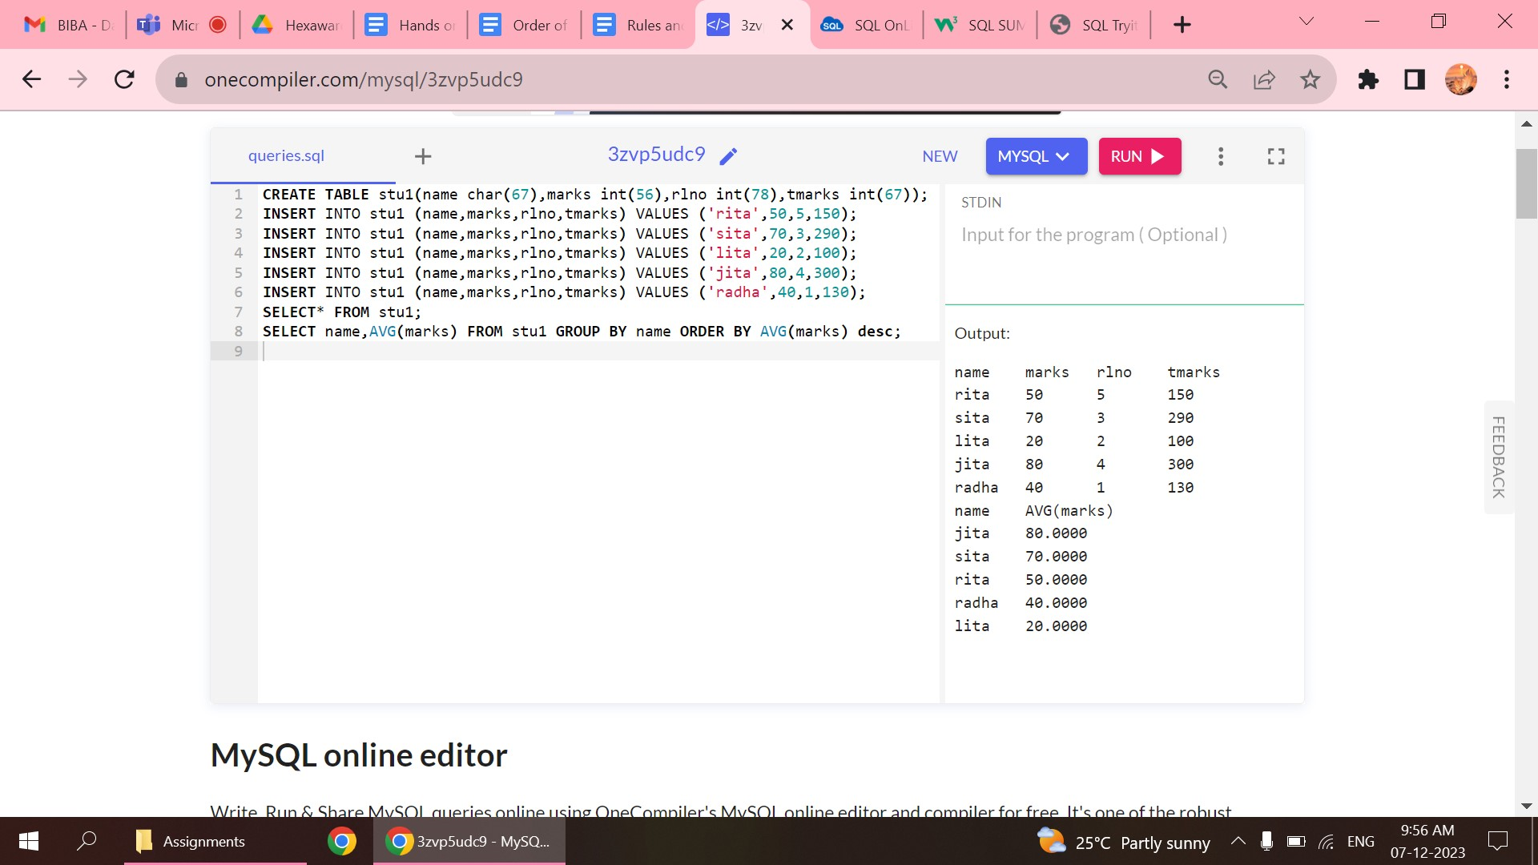

2.MAXIMUM

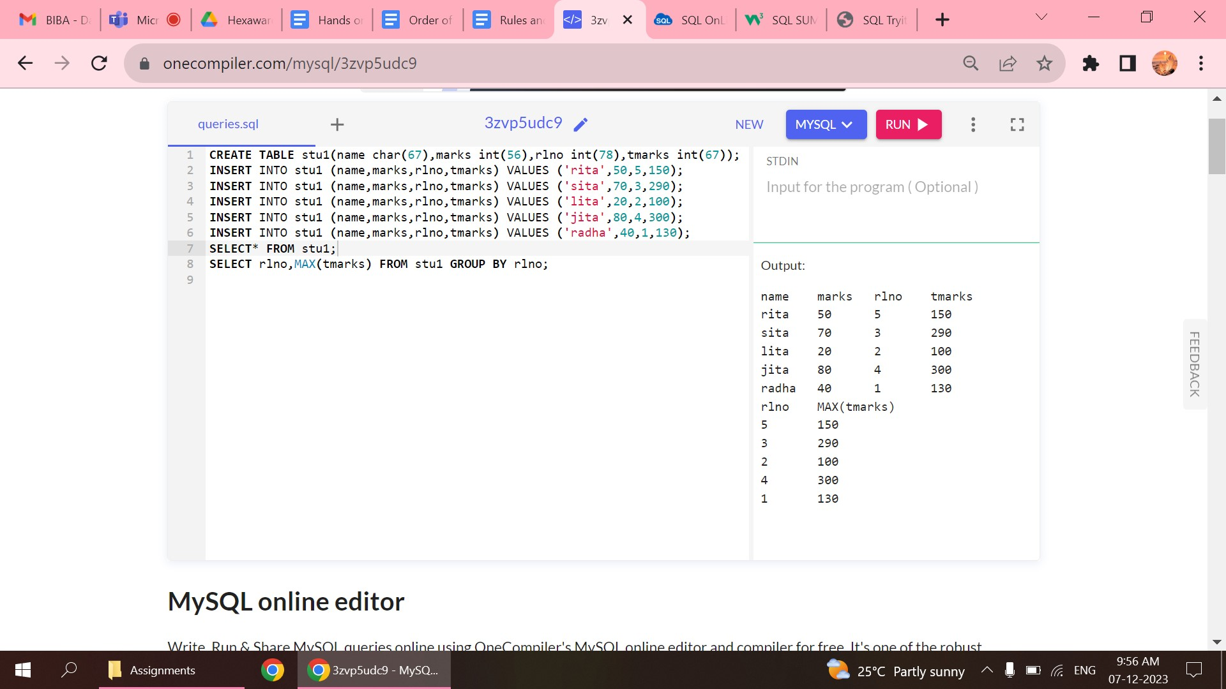

3.MINIMUM

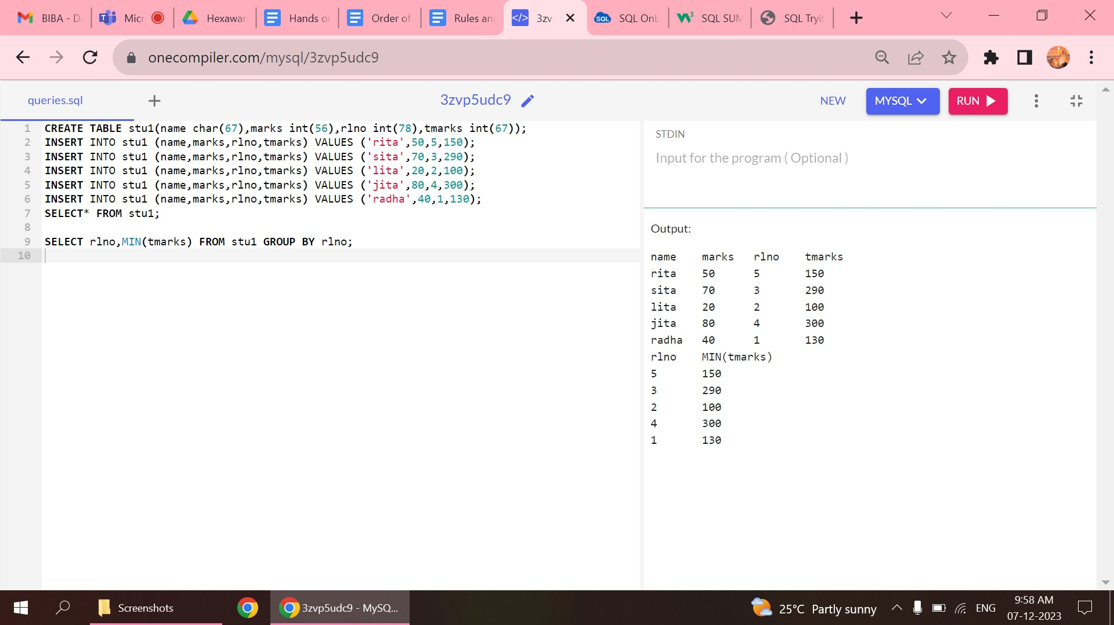

4.COUNT

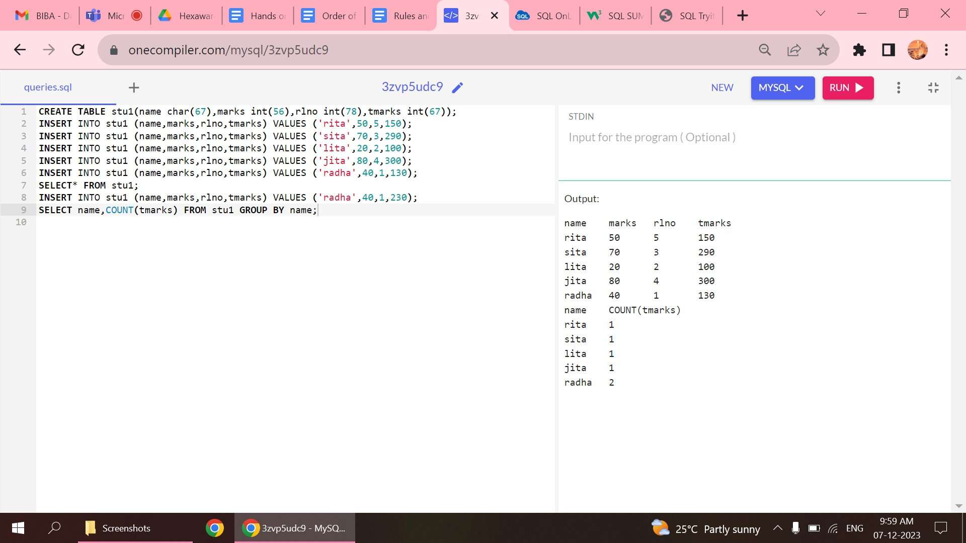

5.SUM

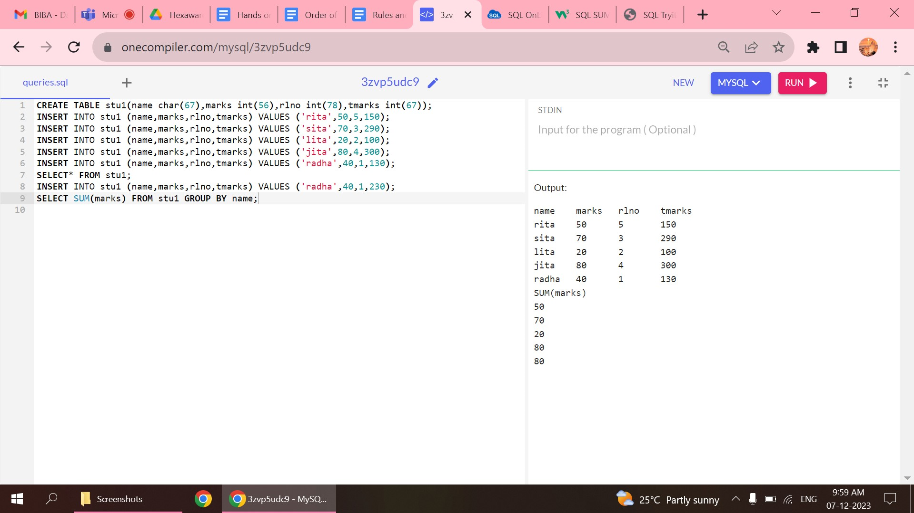

6.DISTINCT

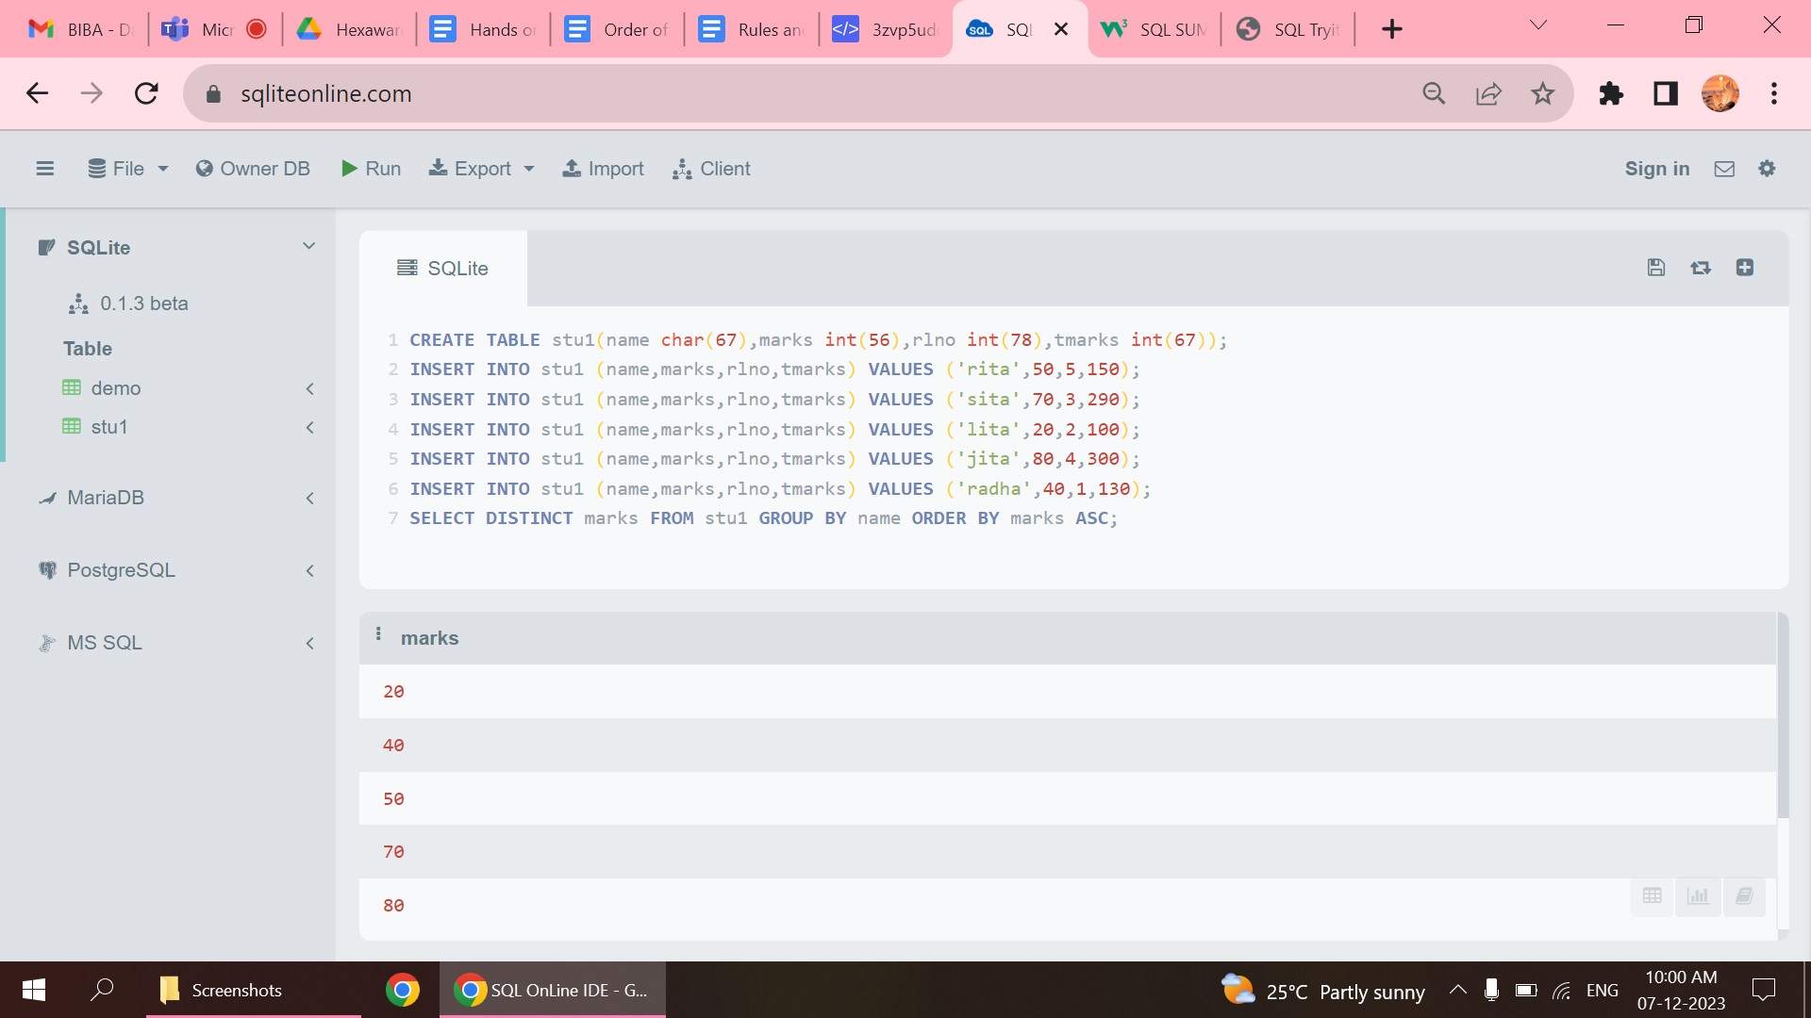

JOINS

1.INNER JOIN

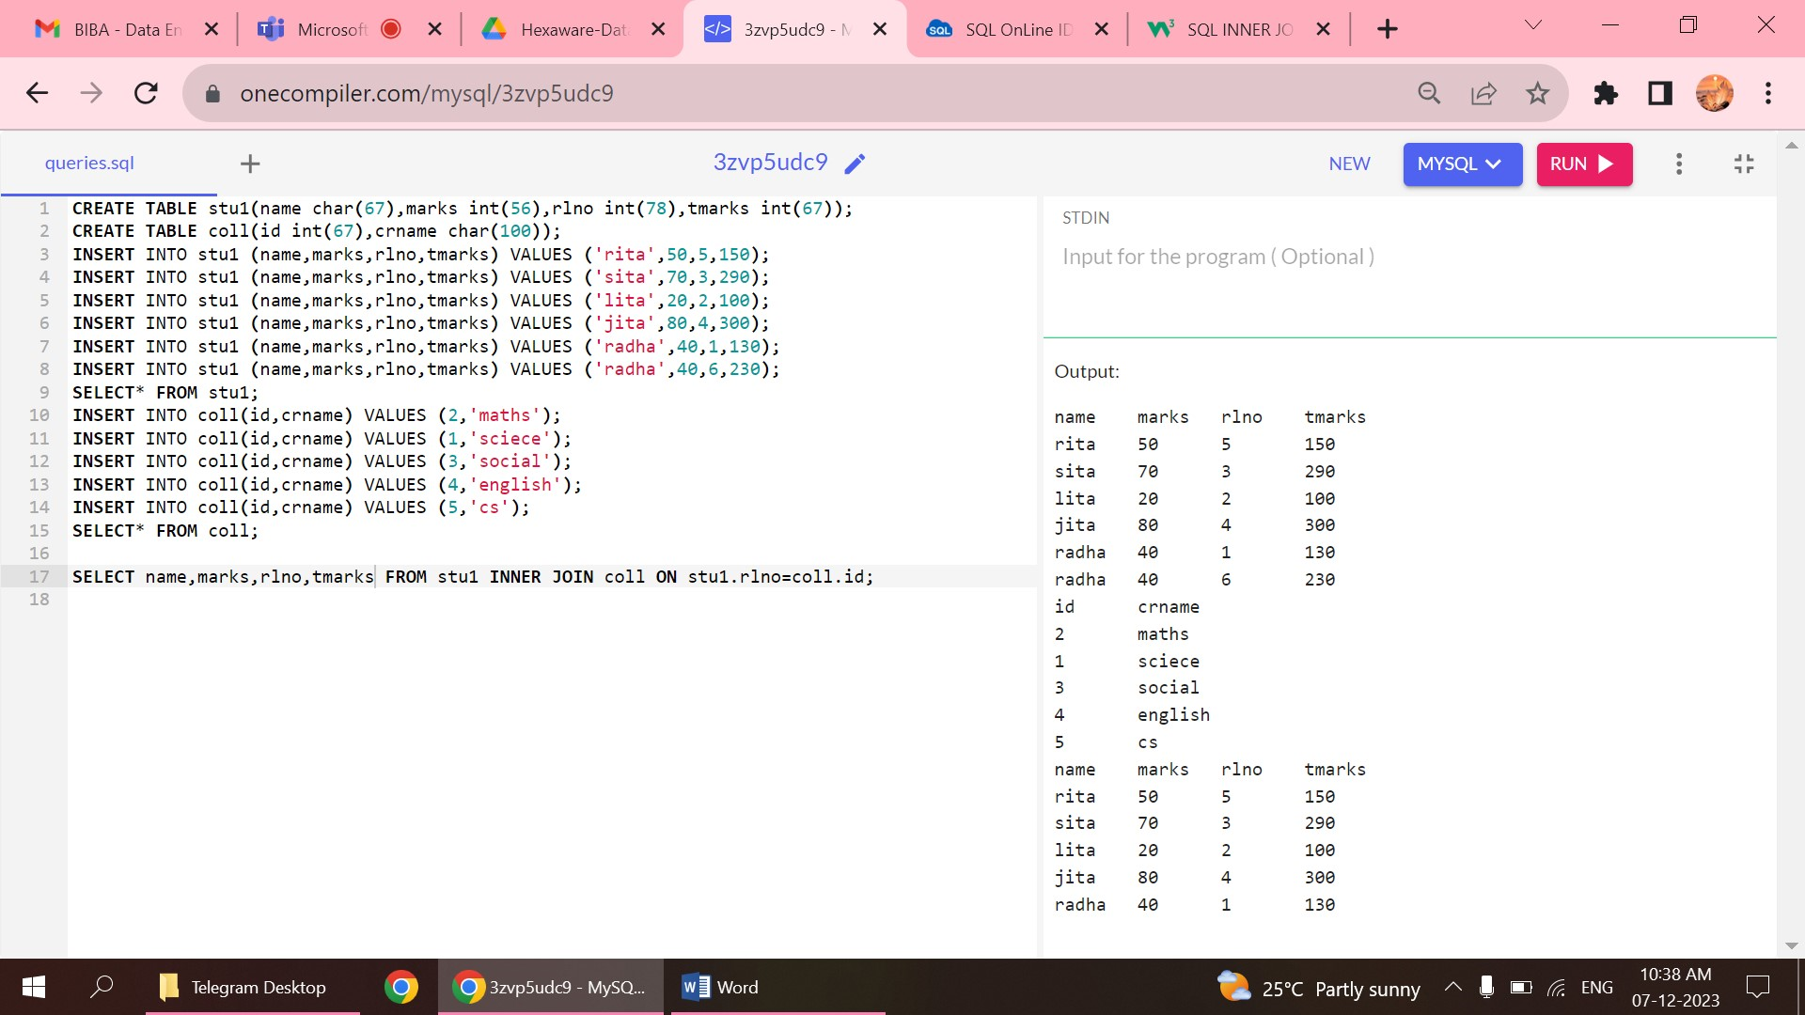

* Selects matching value from both the tables

2.LEFT JOIN

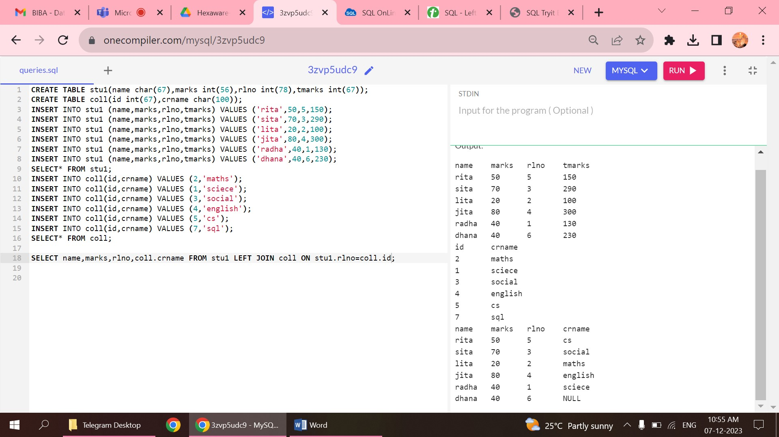

* Returns records from left table with records matching in right table and returns null value if there is no matching records from right side table.

3.RIGHT JOIN

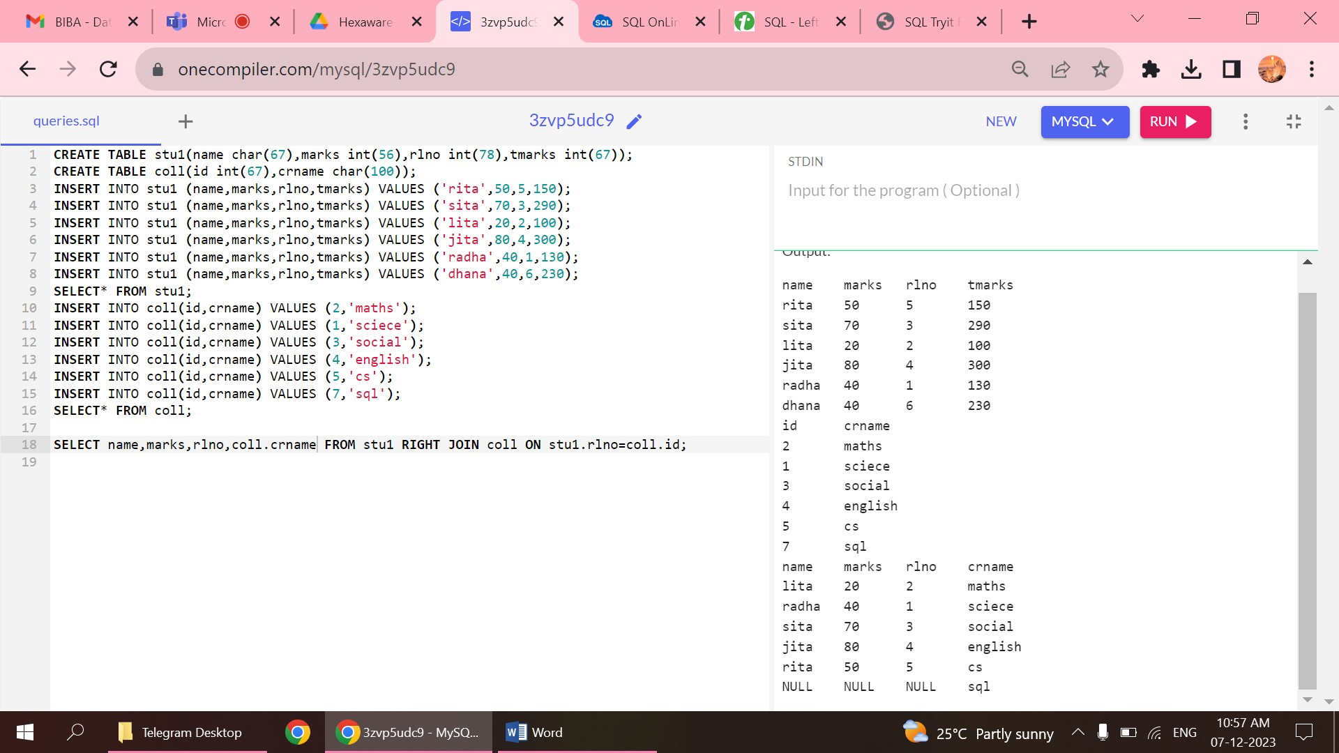

* Returns records from right table with matching values from left table and returns null value if there is no matching records from left side table.

4.FULL JOIN

* New table is created by joining all values from both the values
* Null value is returned for the missing values that is not matching from either of the tables.

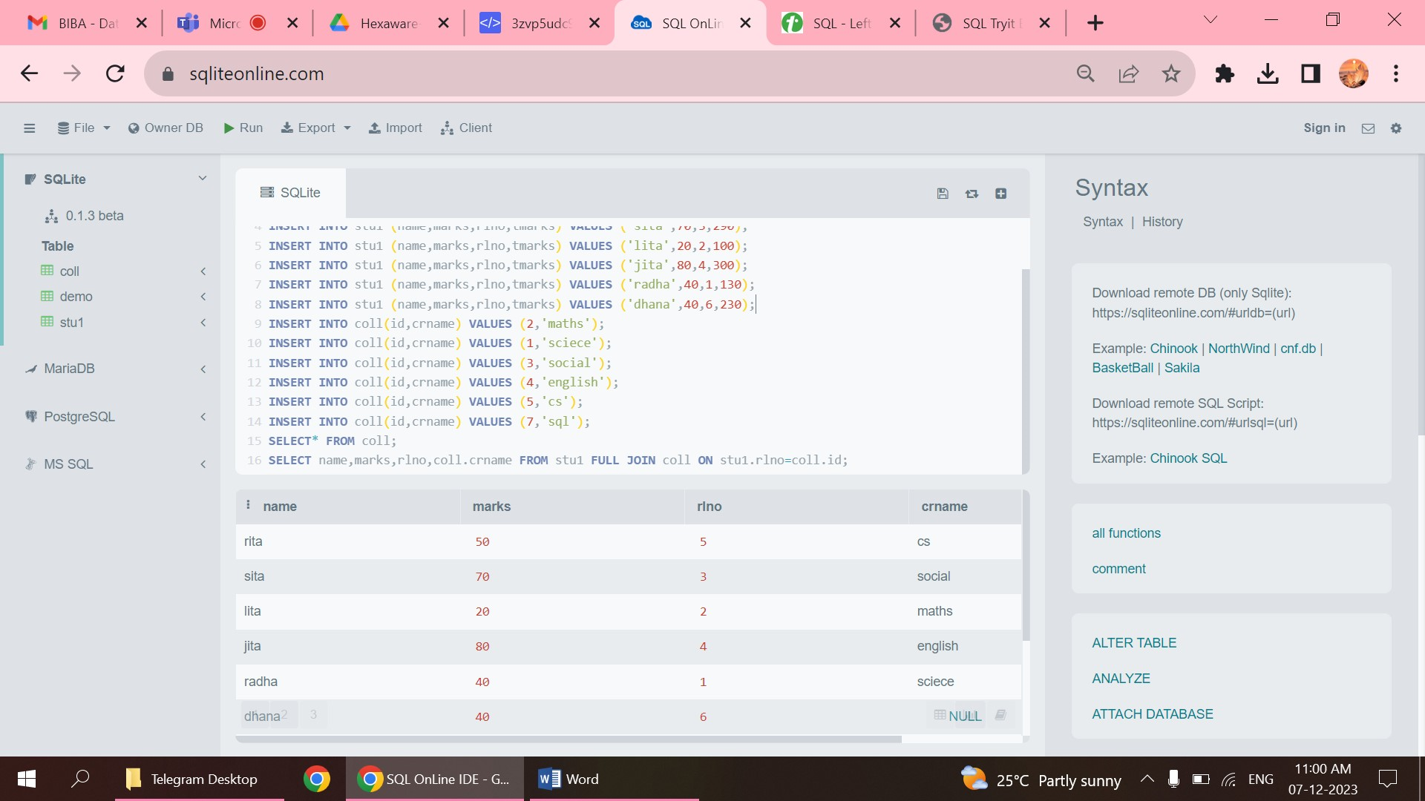

5.NATURAL JOIN

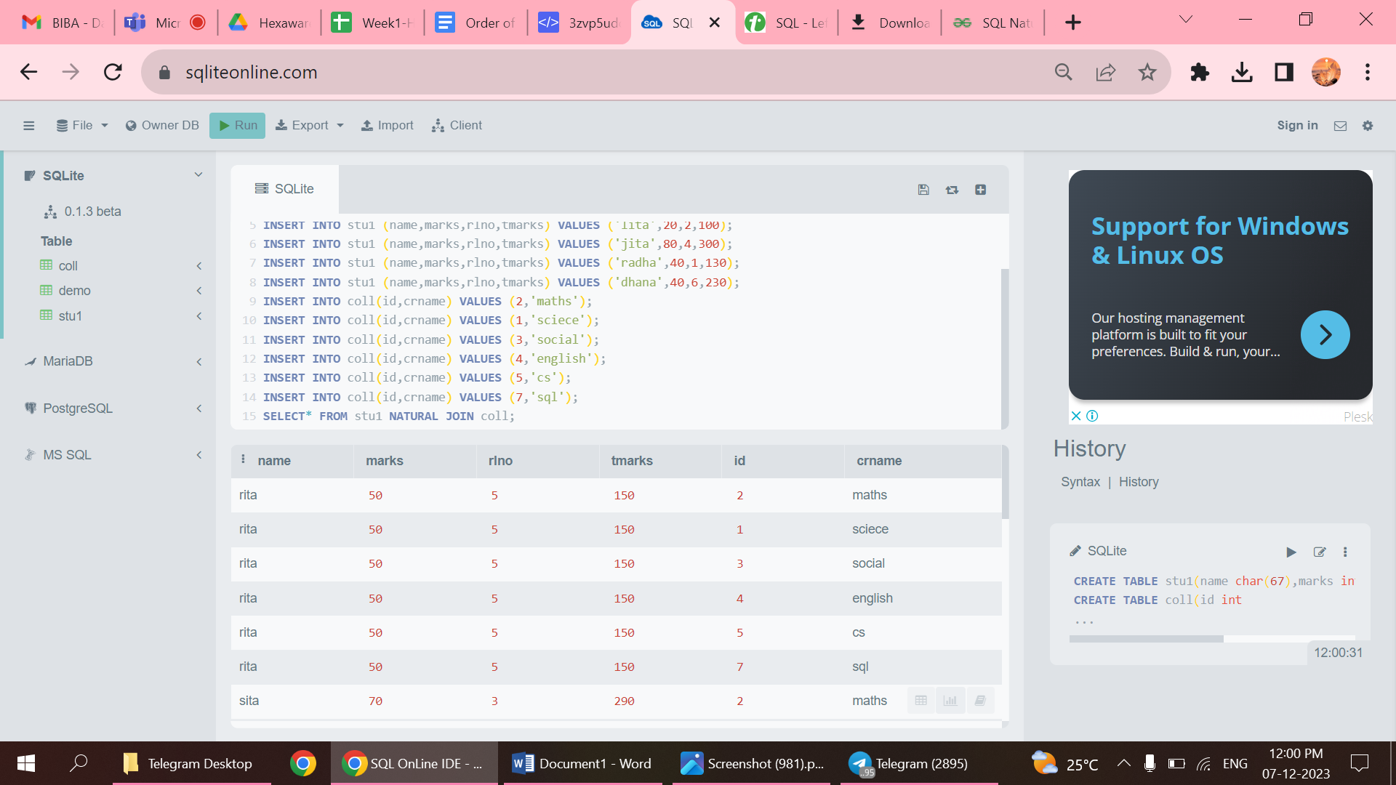

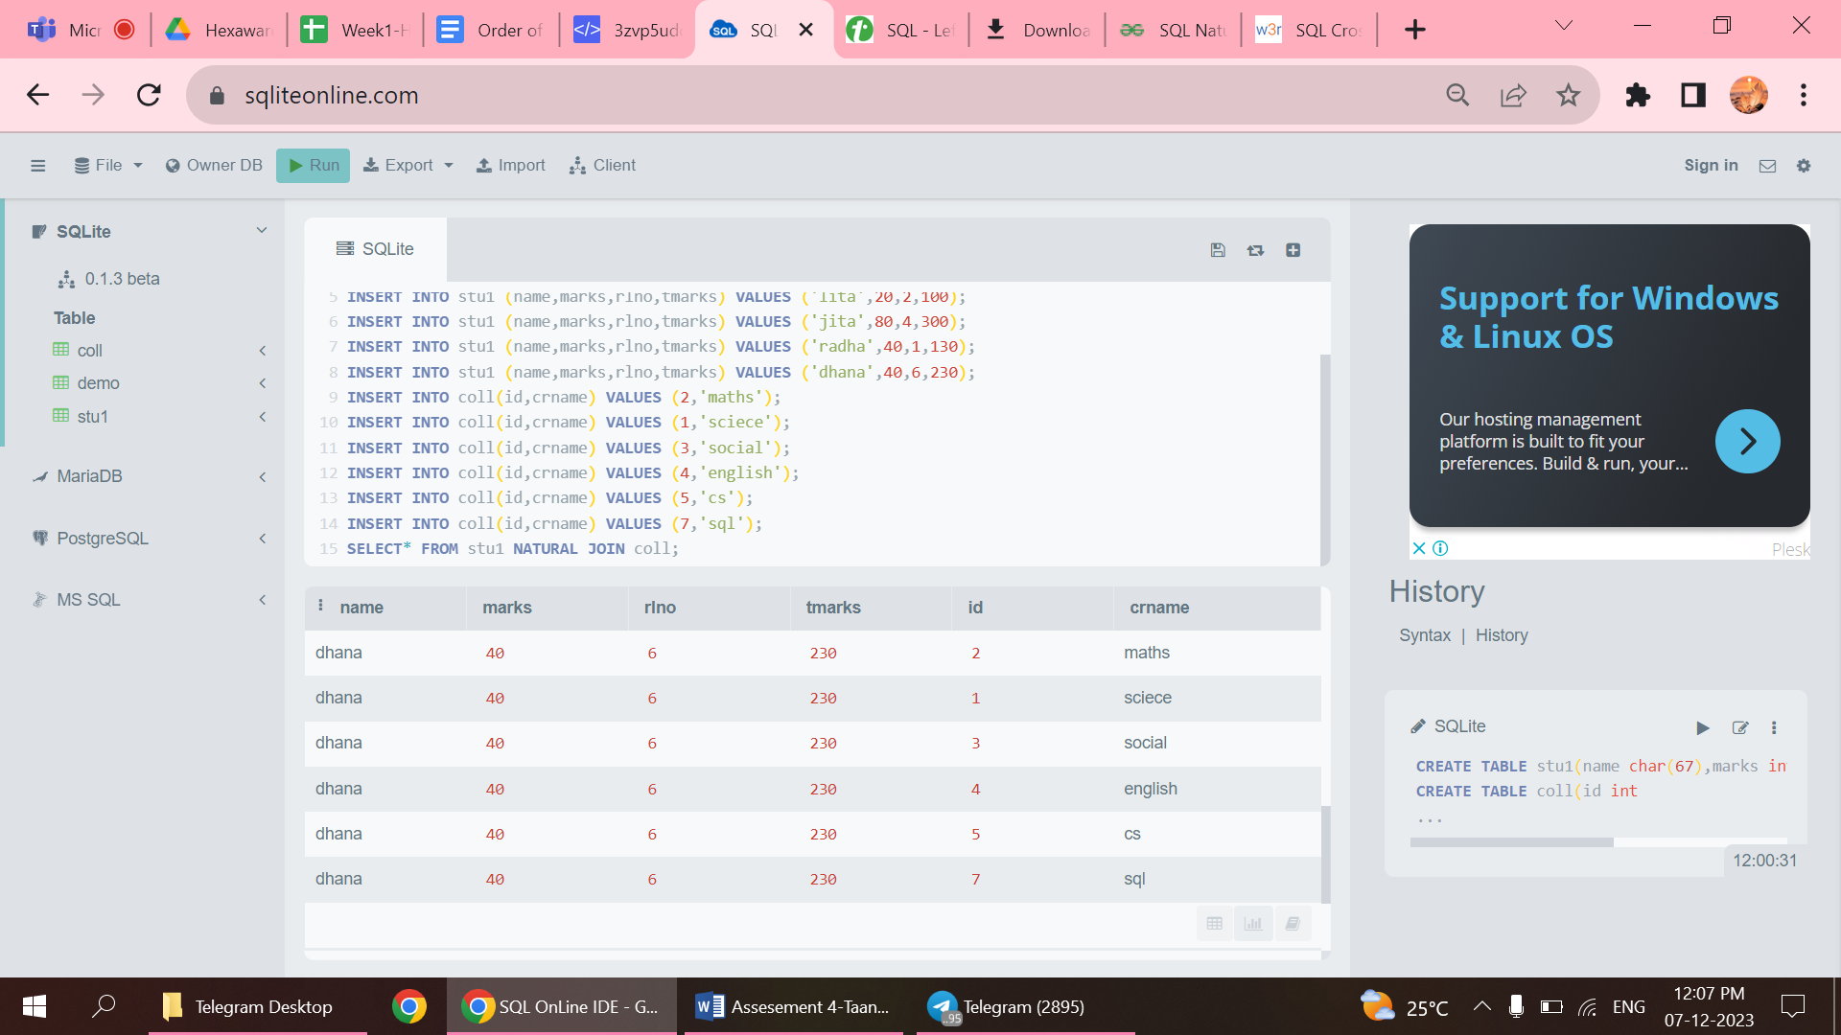

* Join rows based on the common columns in both the tables.

6.CROSS JOIN

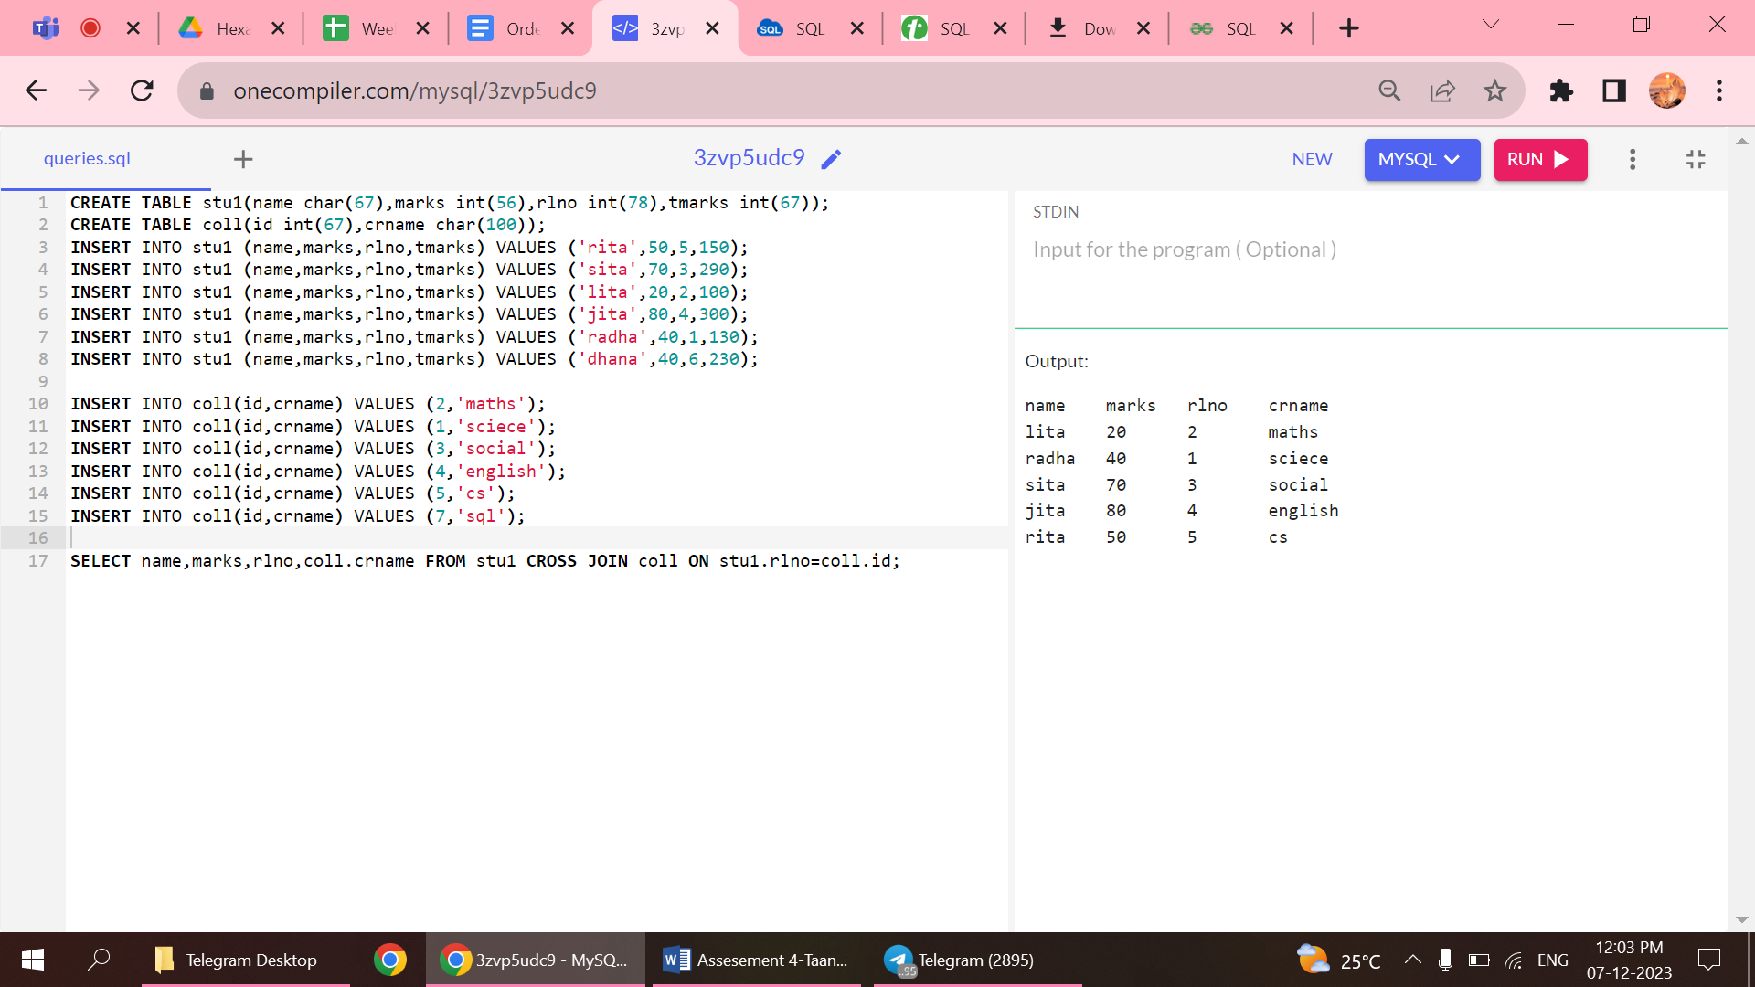

* Returns records from both the tables.

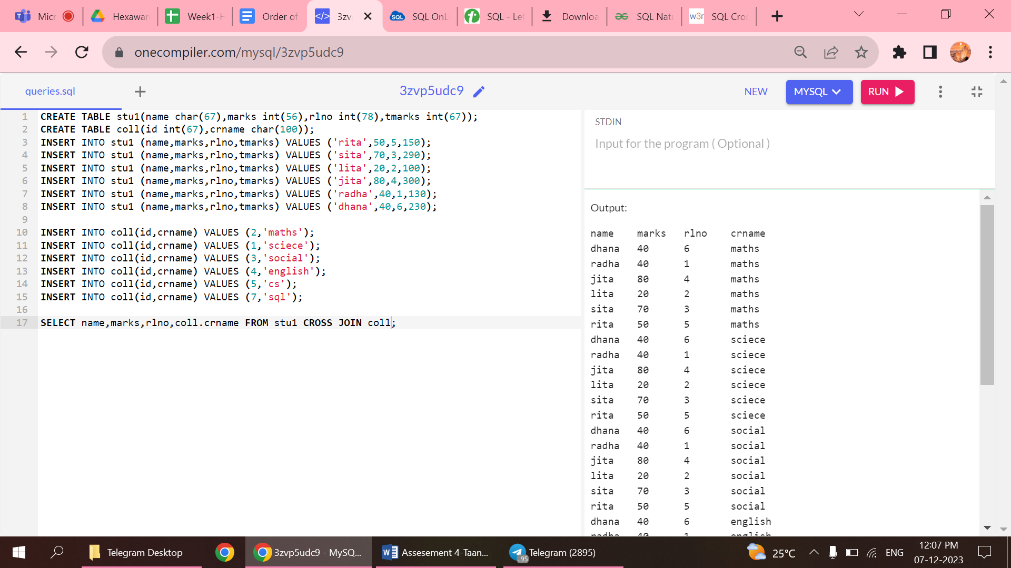

STRING FUNCTIONS

1.ASCII

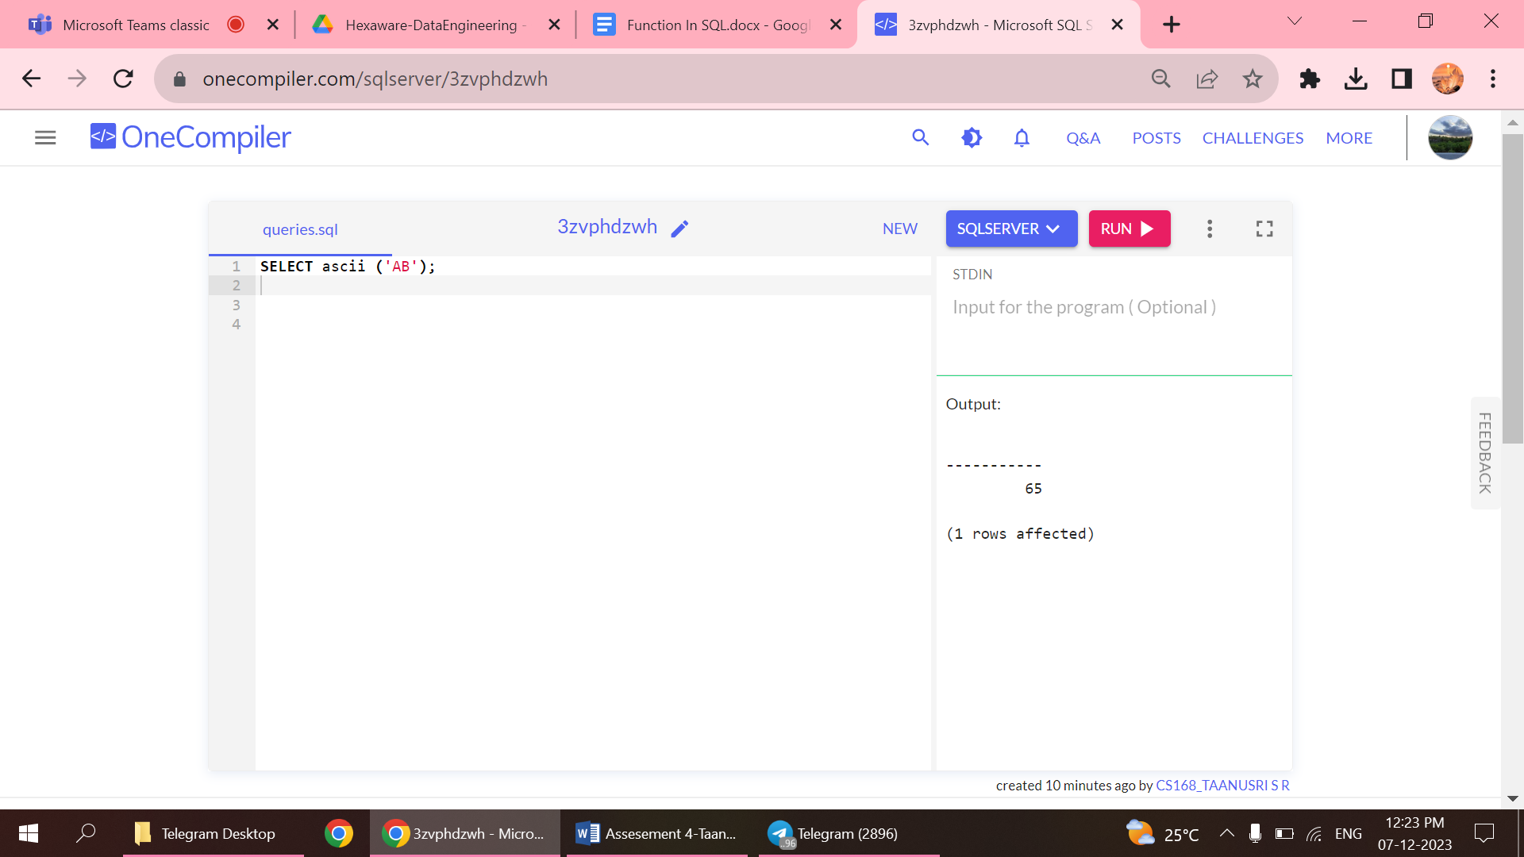

2.CHAR

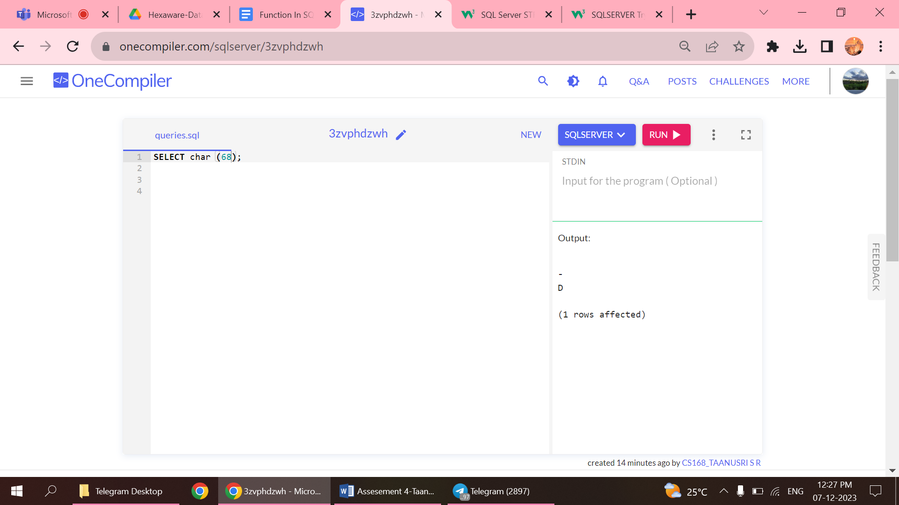

3.LENGTH

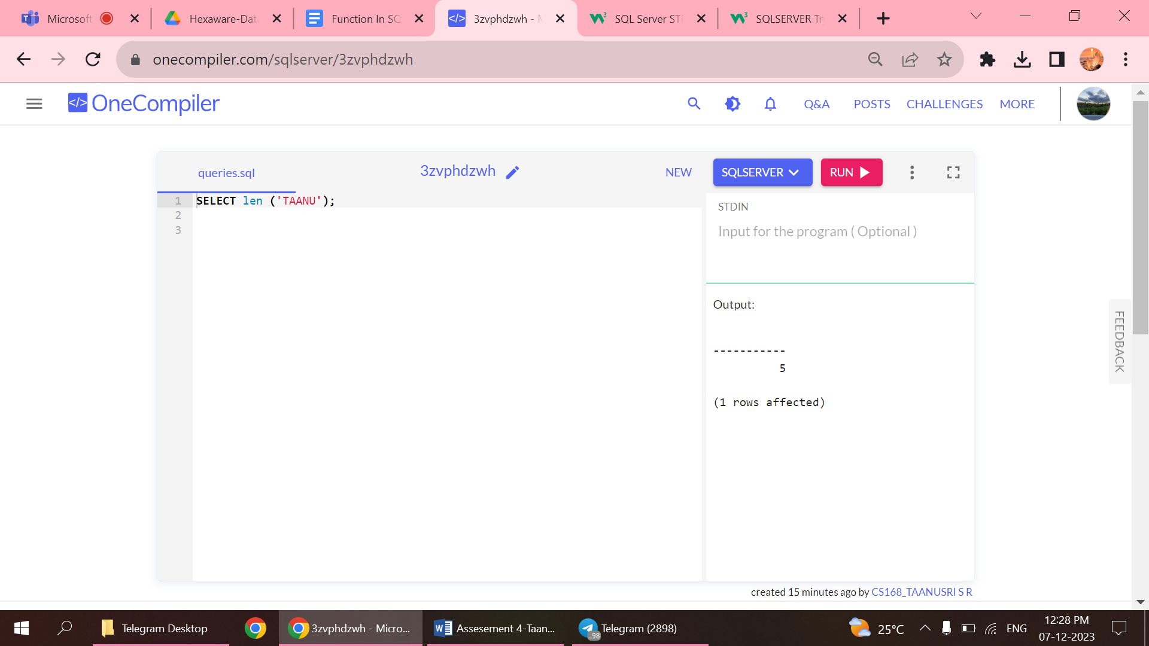

4.LOWER

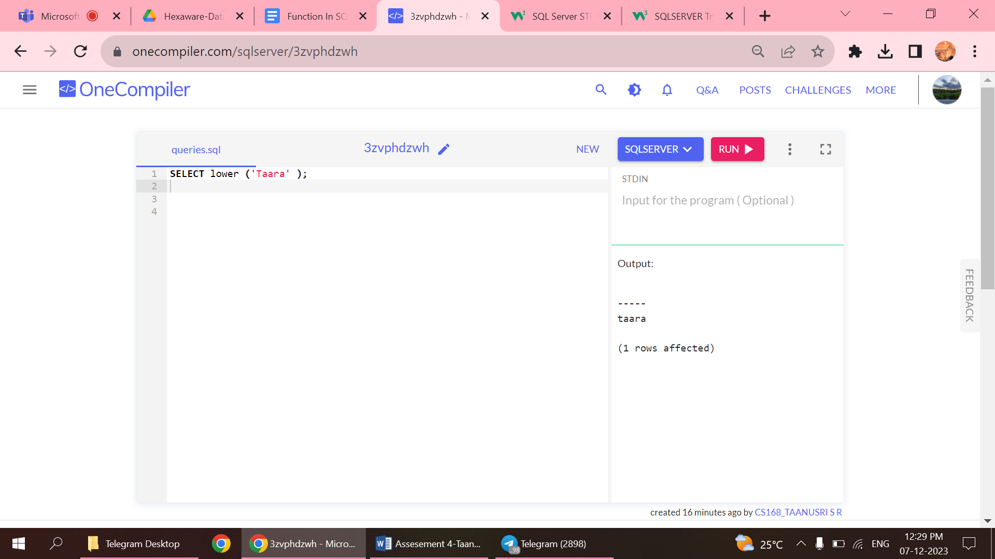

5.REPLACE

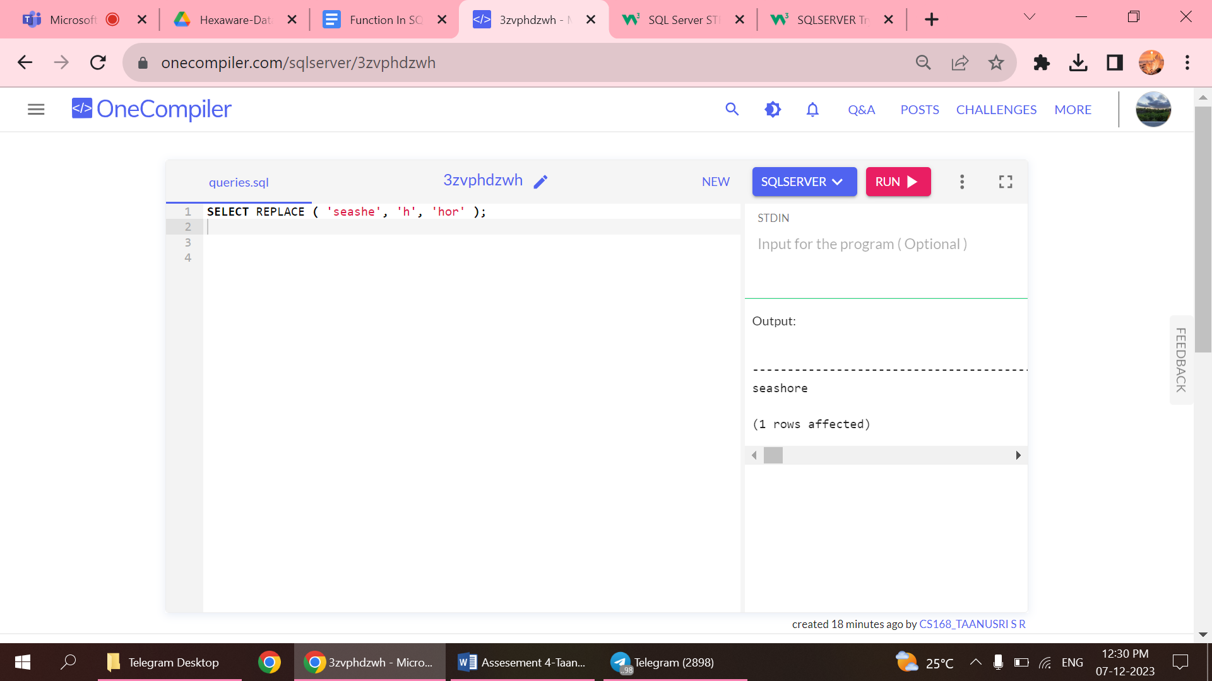

6.REVERSE

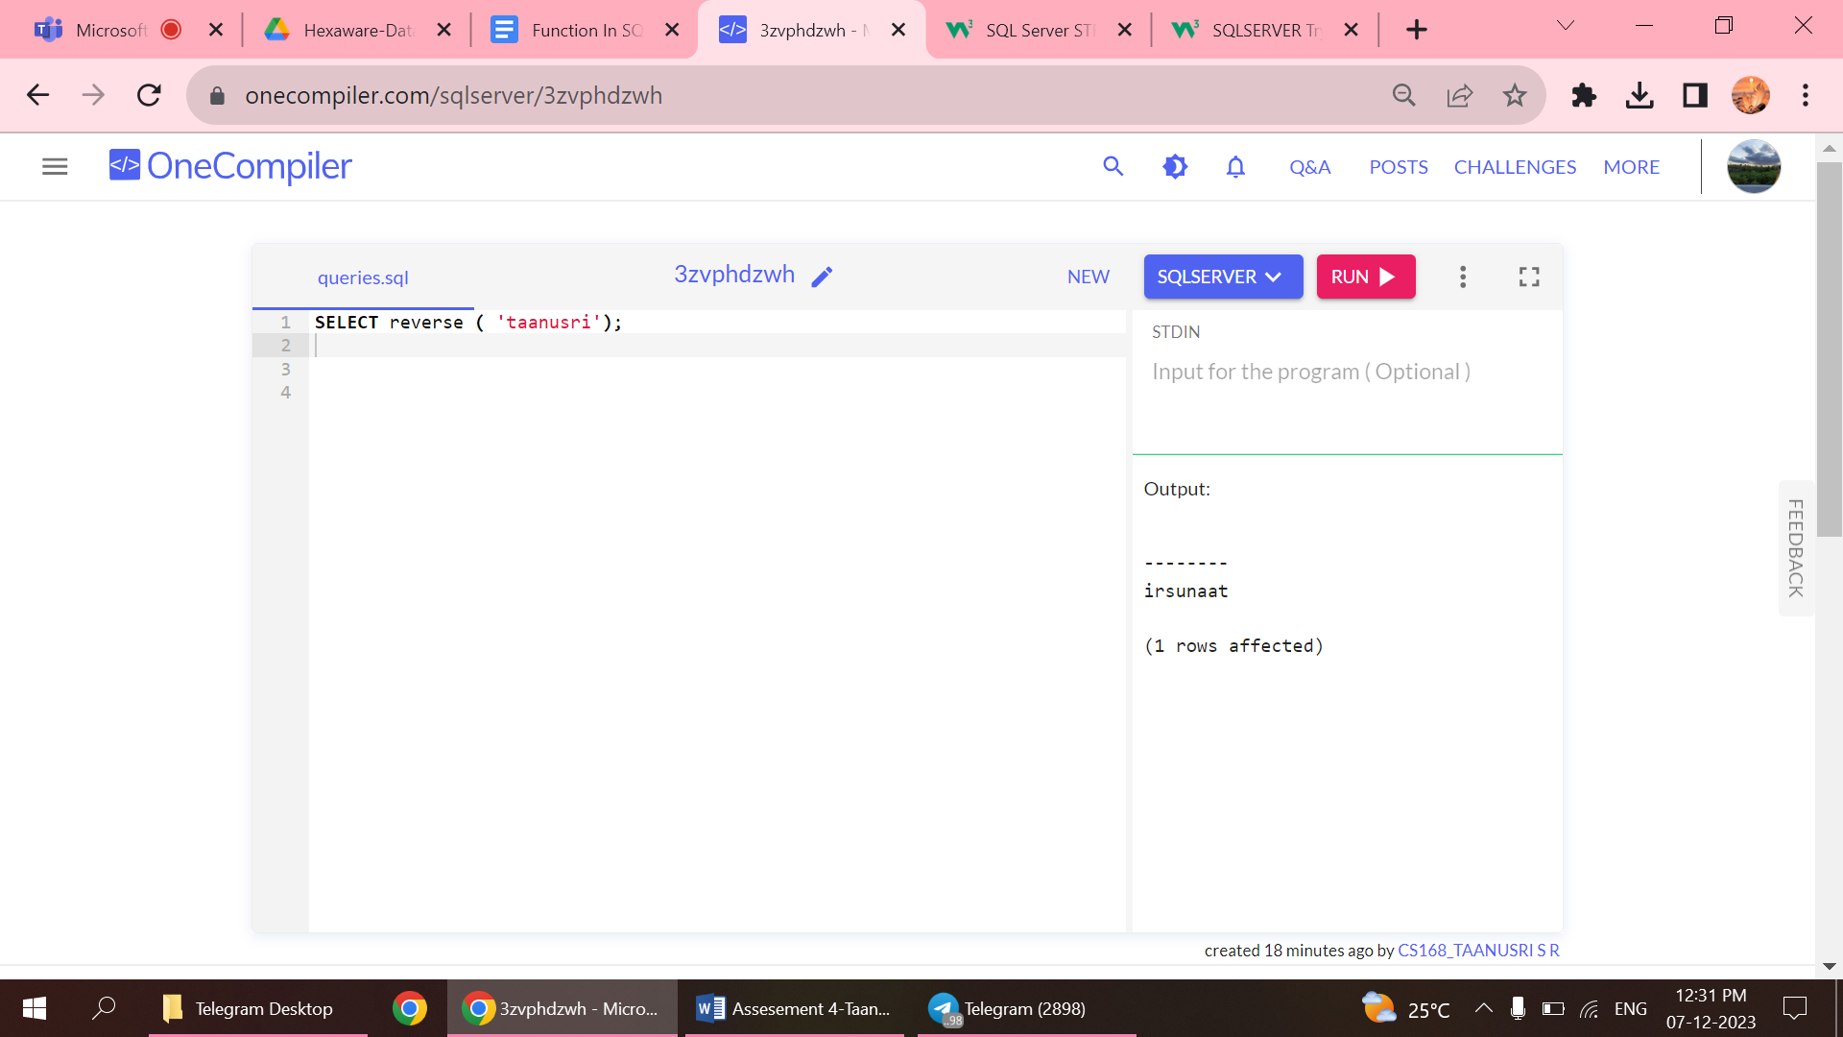

7.STR

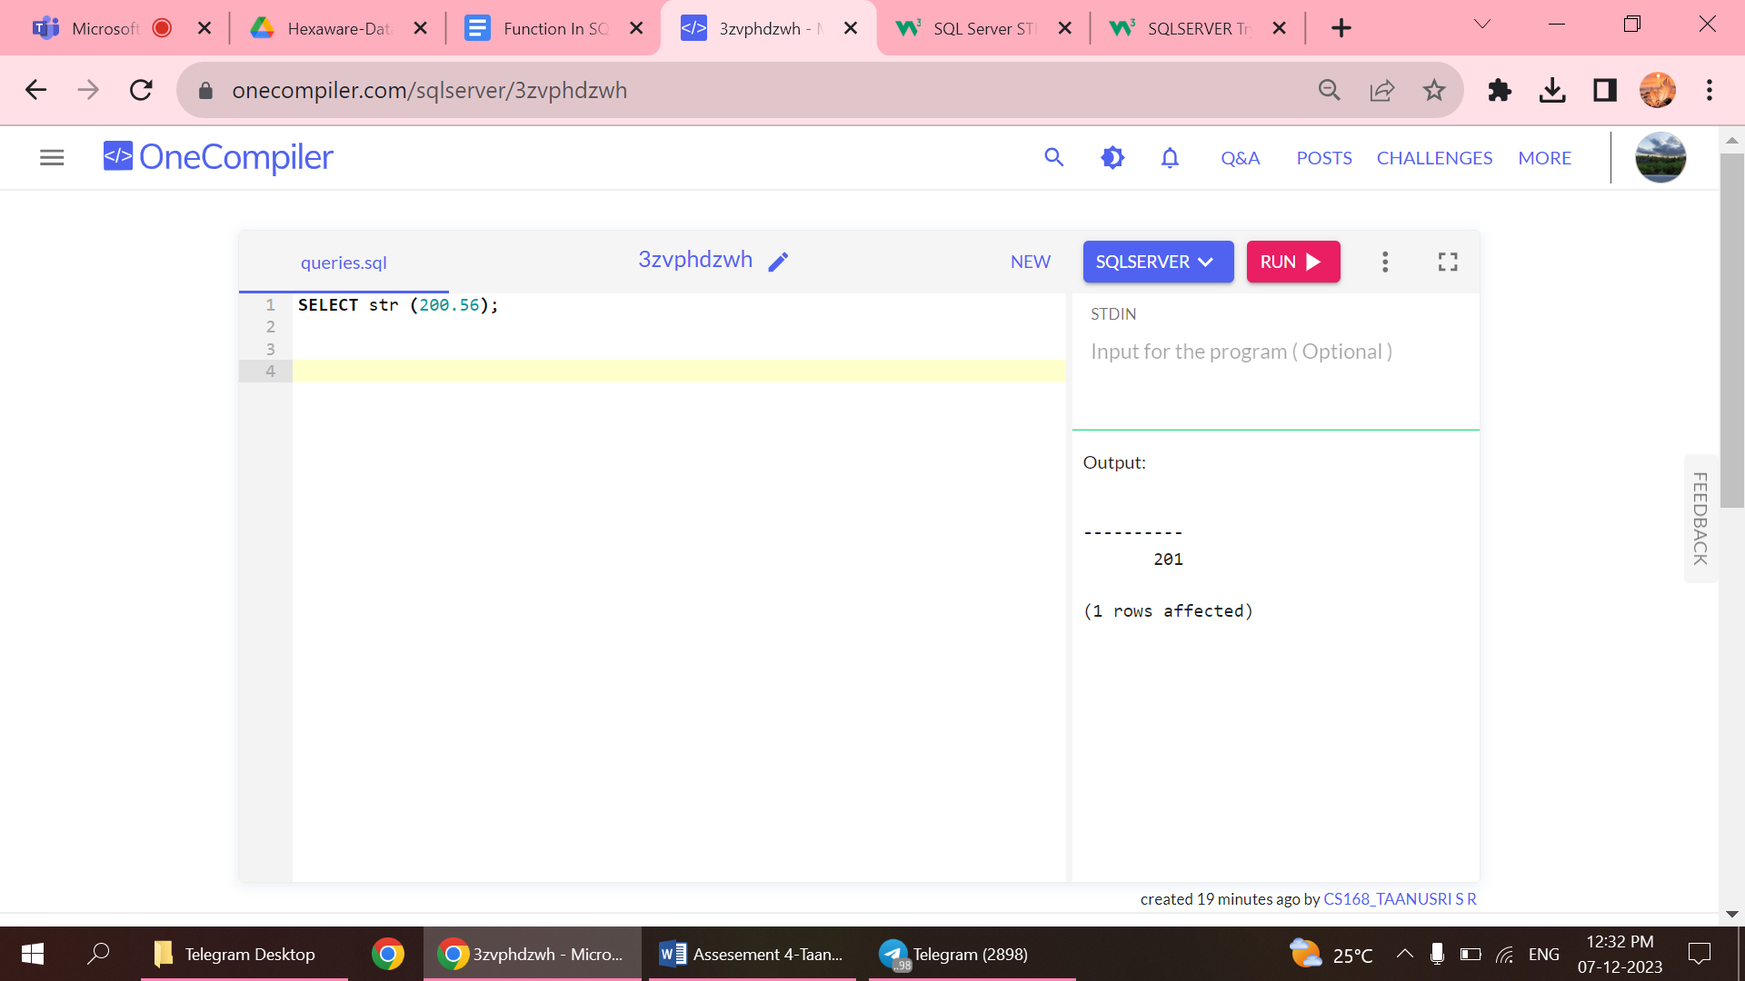

8.UPPER

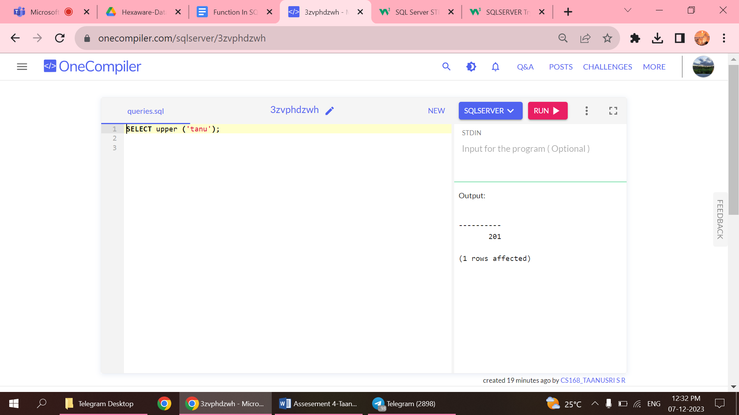

DATE FUNCTIONS

1.DATE ADD

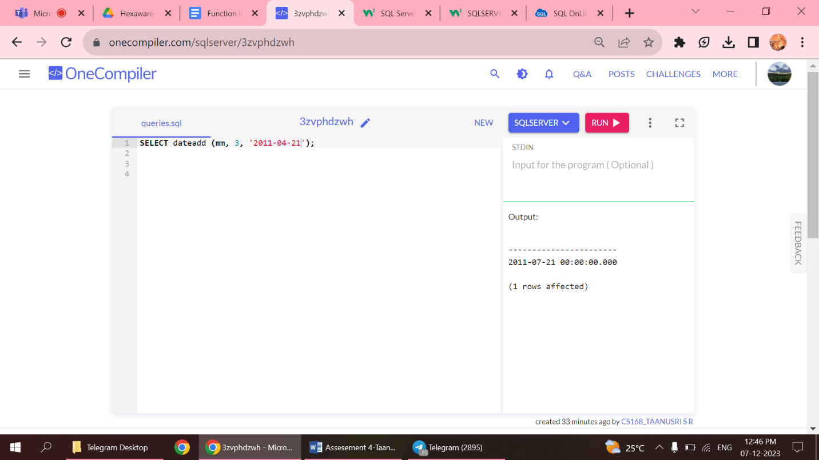

2.DATE DIFF

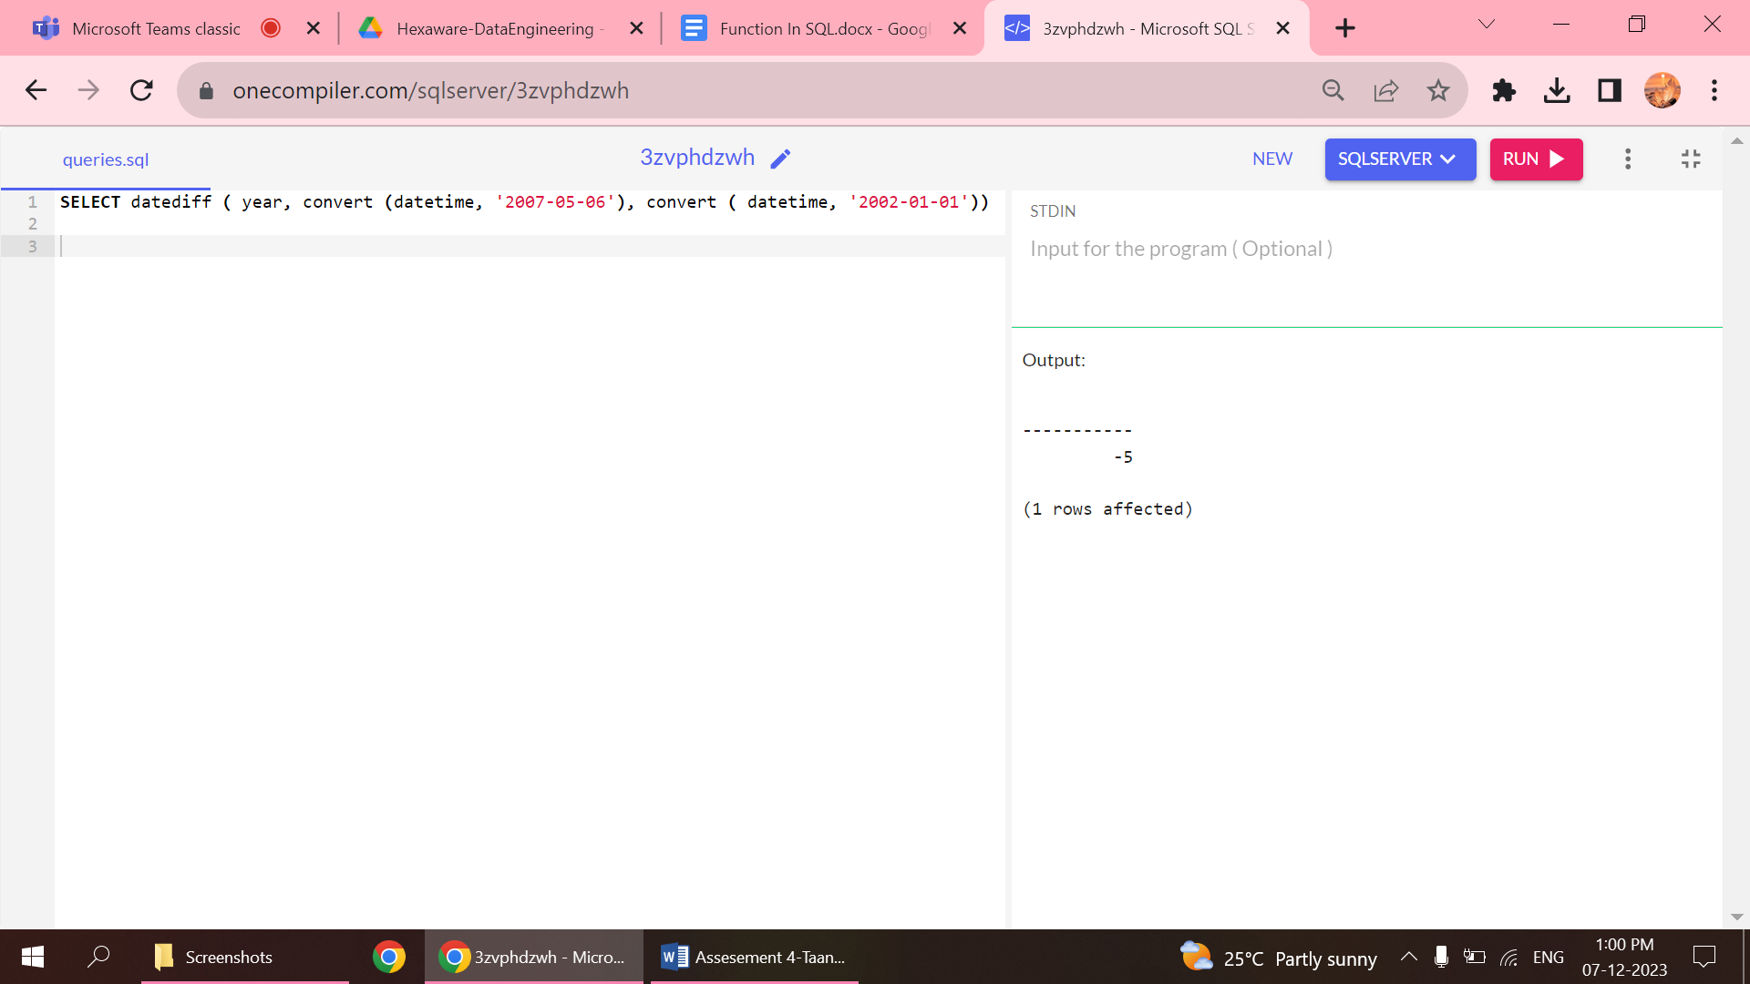

3.DATEPART

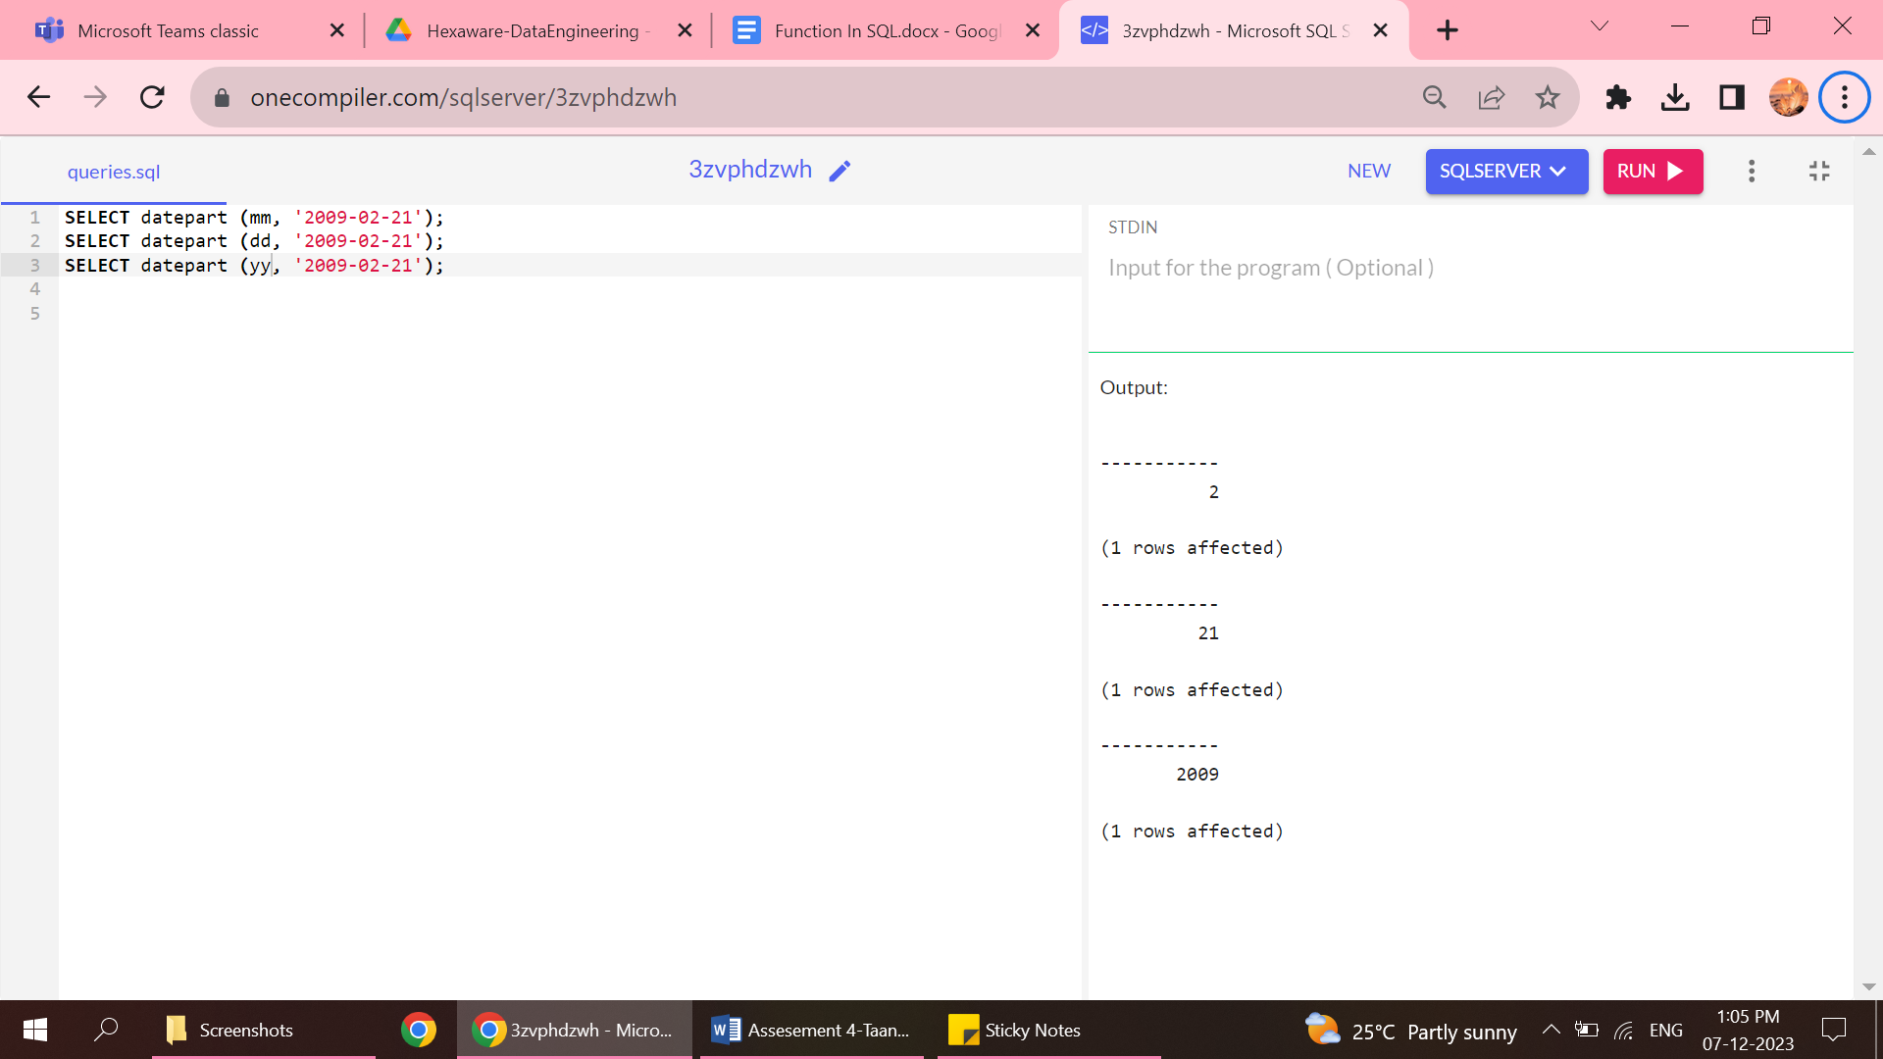

4.DAY

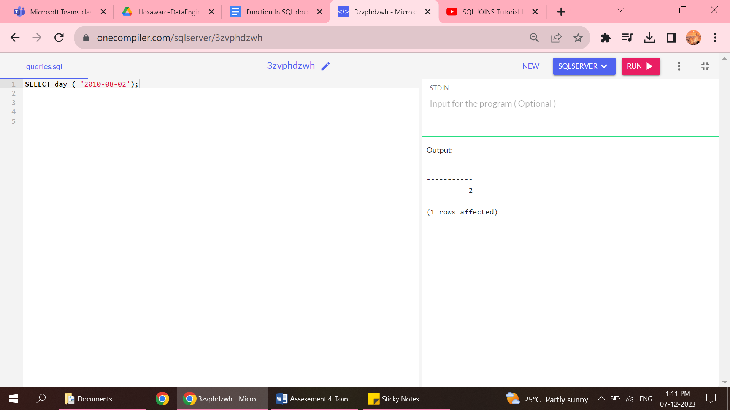

5.MONTH

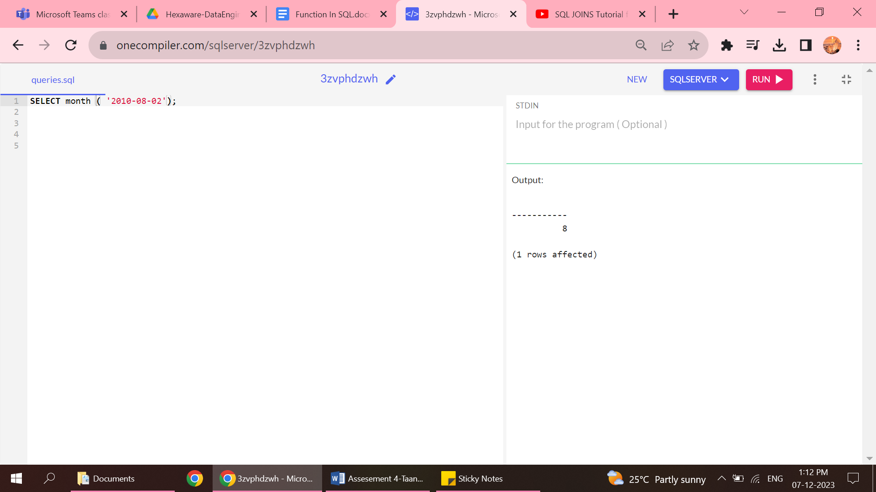

6.YEAR

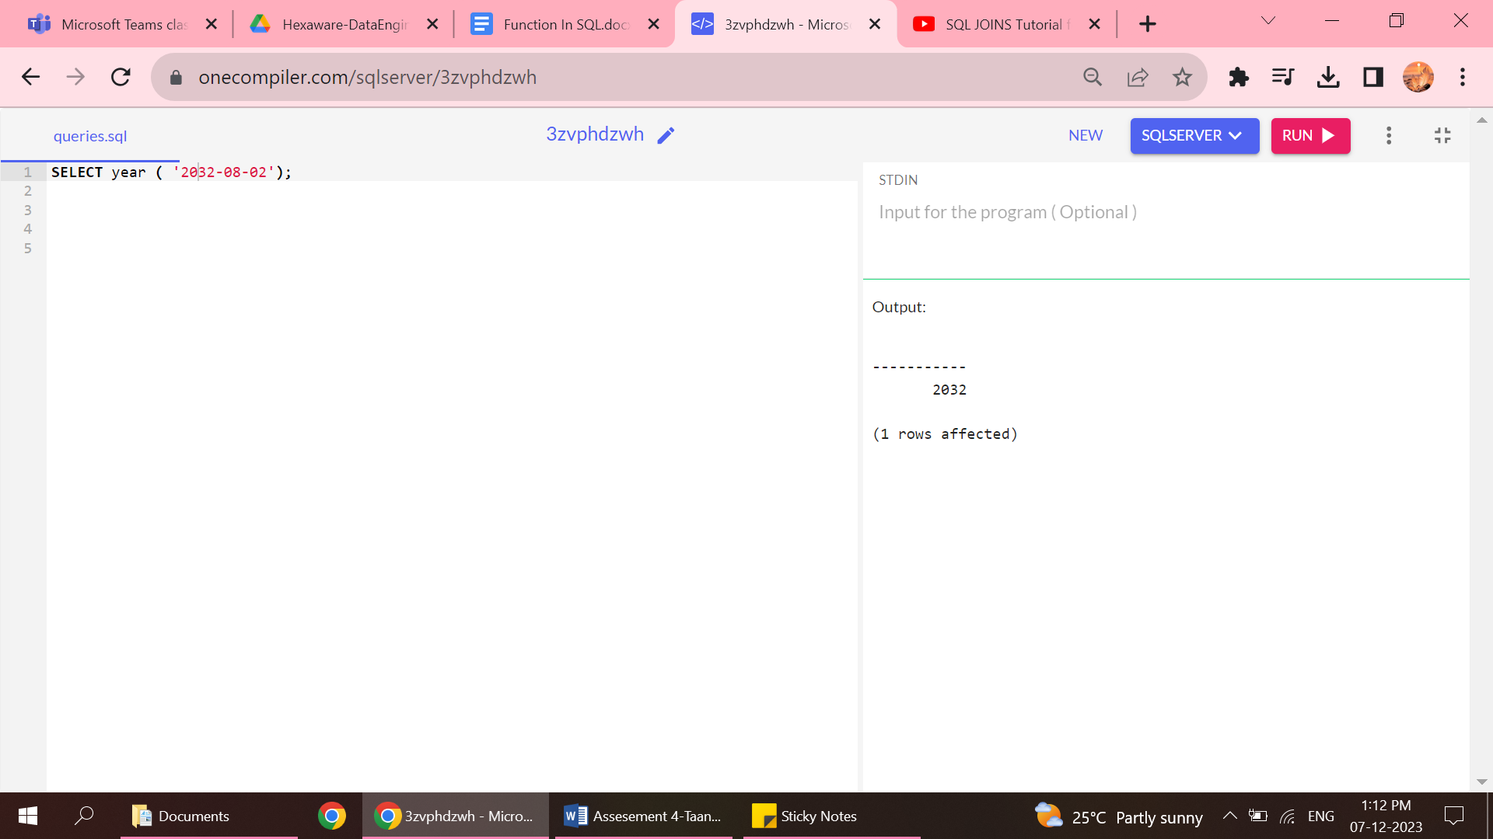

MATHEMATICAL FUNCTIONS

1.ABSOLUTE

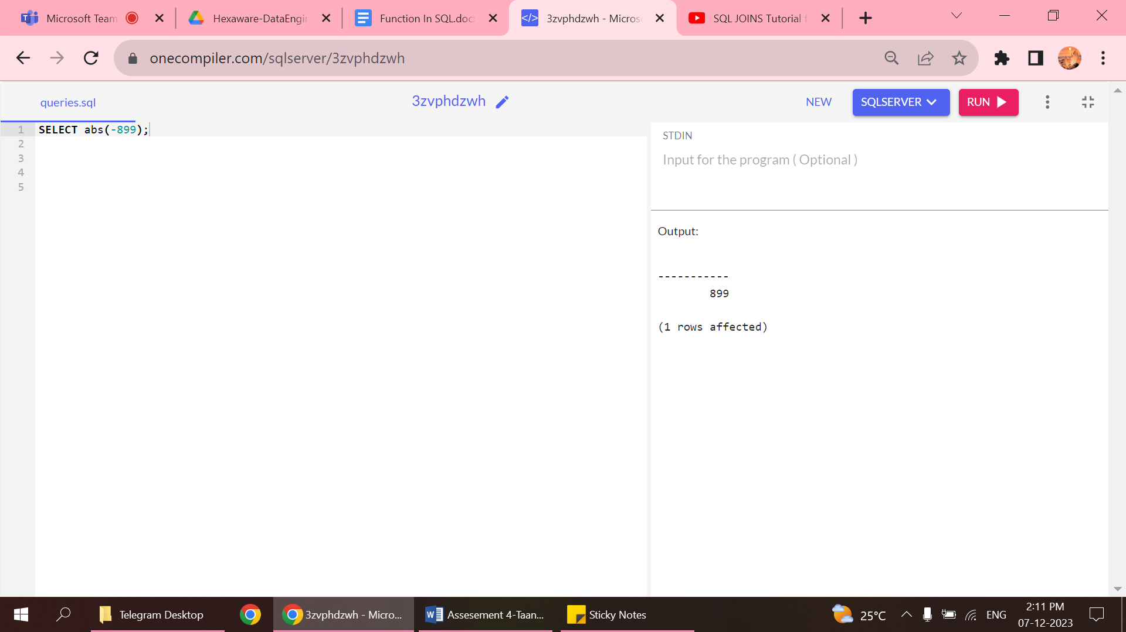

2.ANGLES

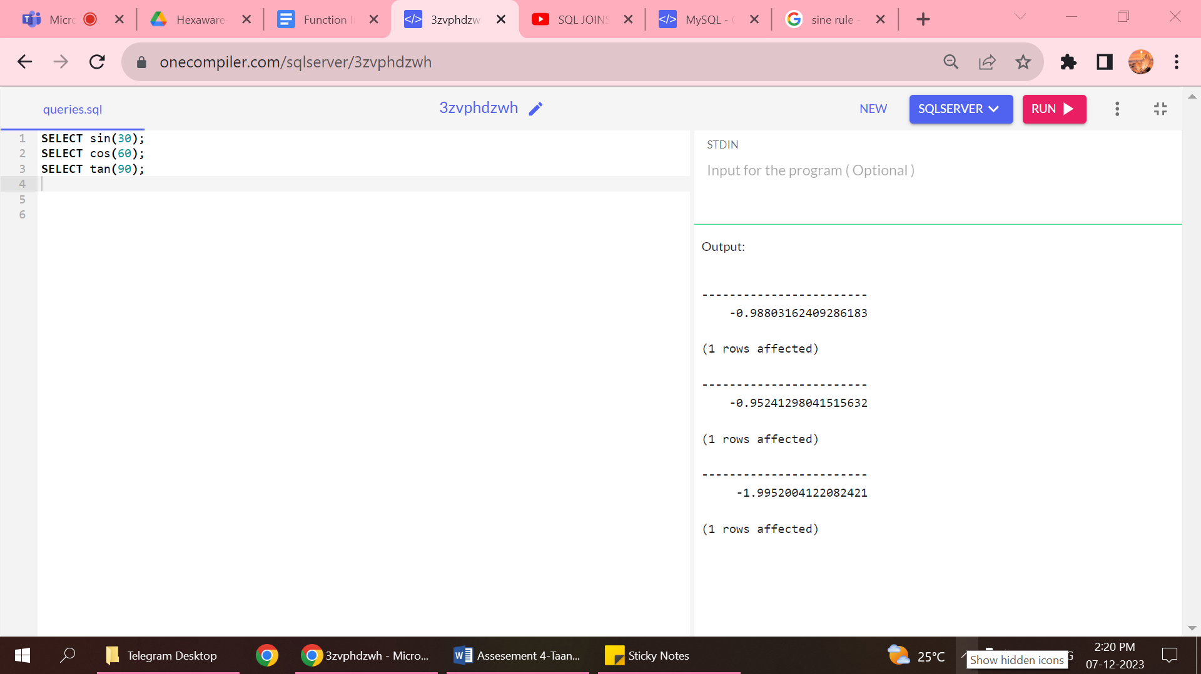

3.CEILING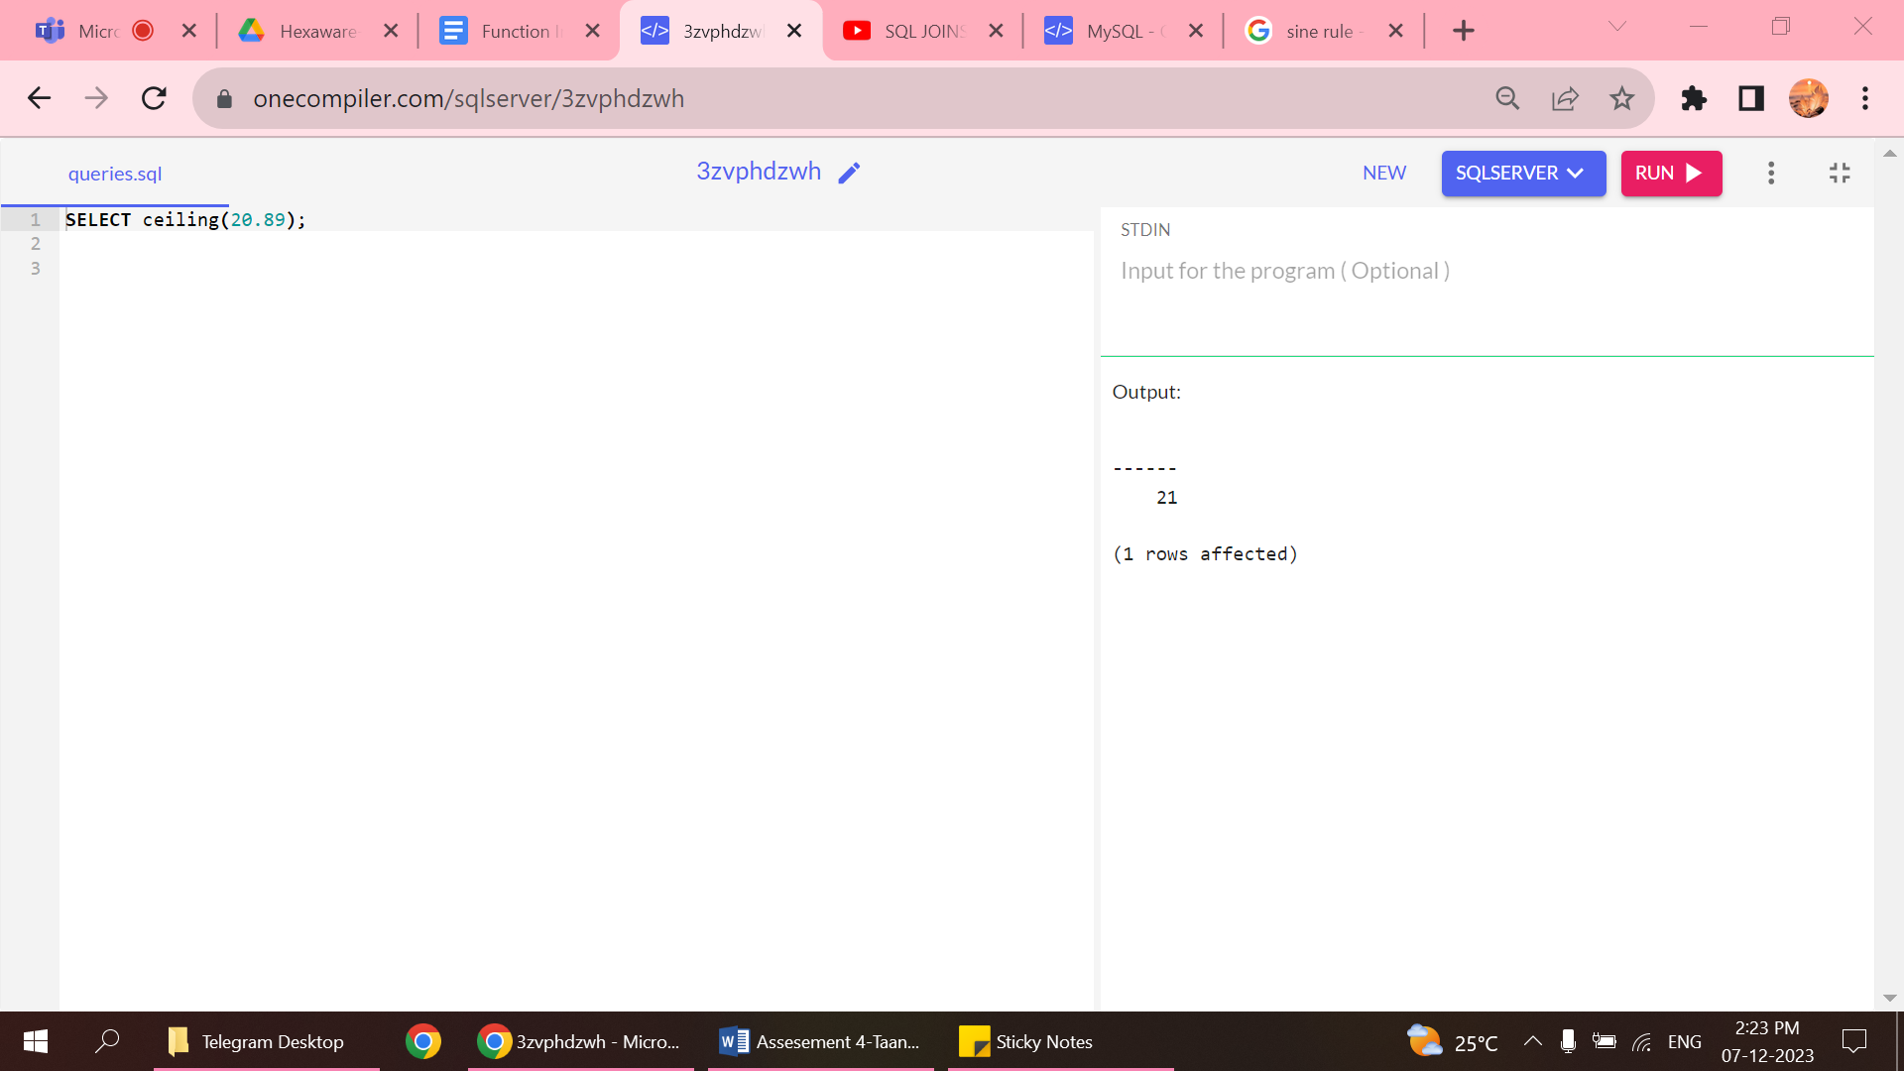

4.EXPONENTIAL

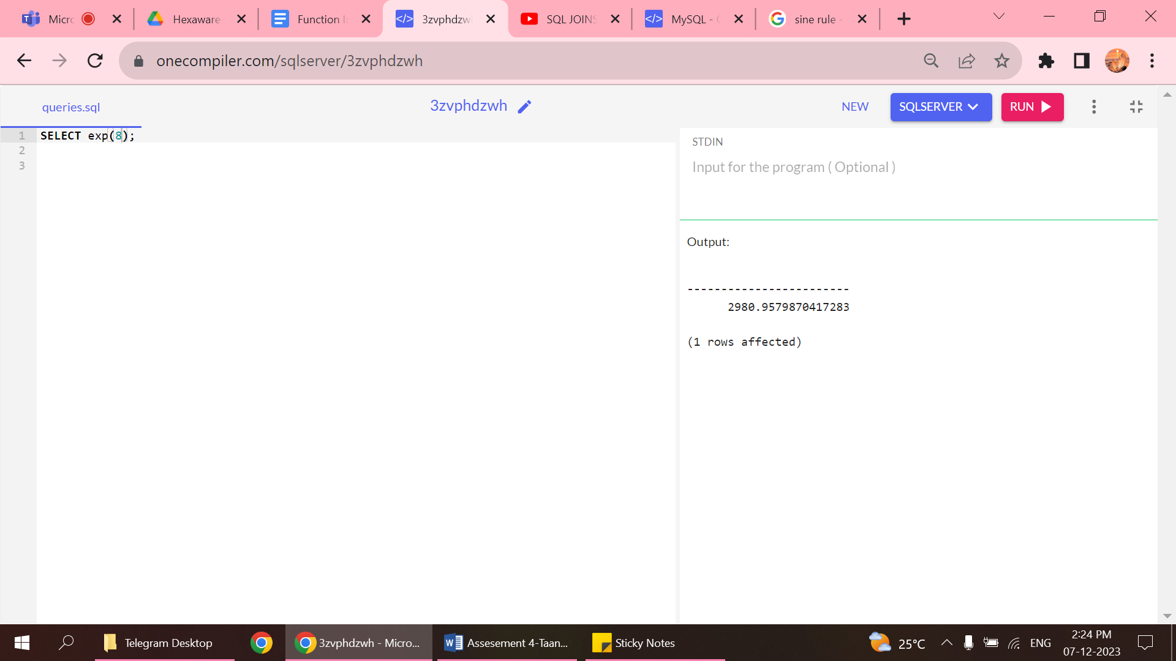

5.FLOOR

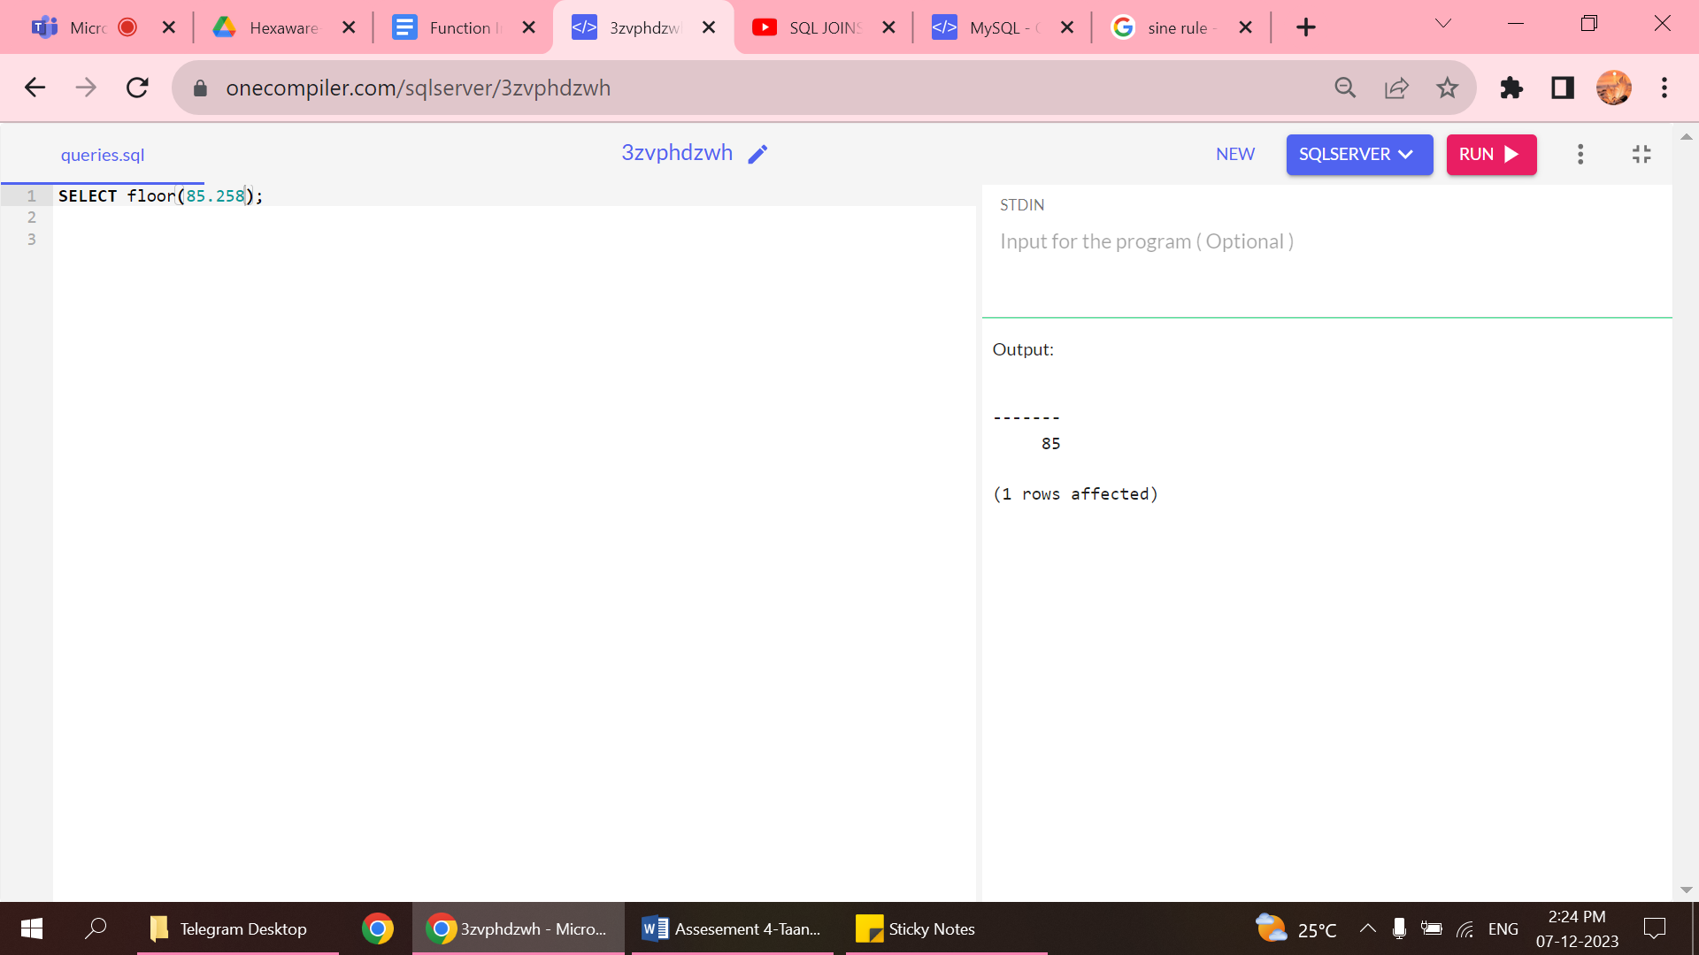

6.LOG

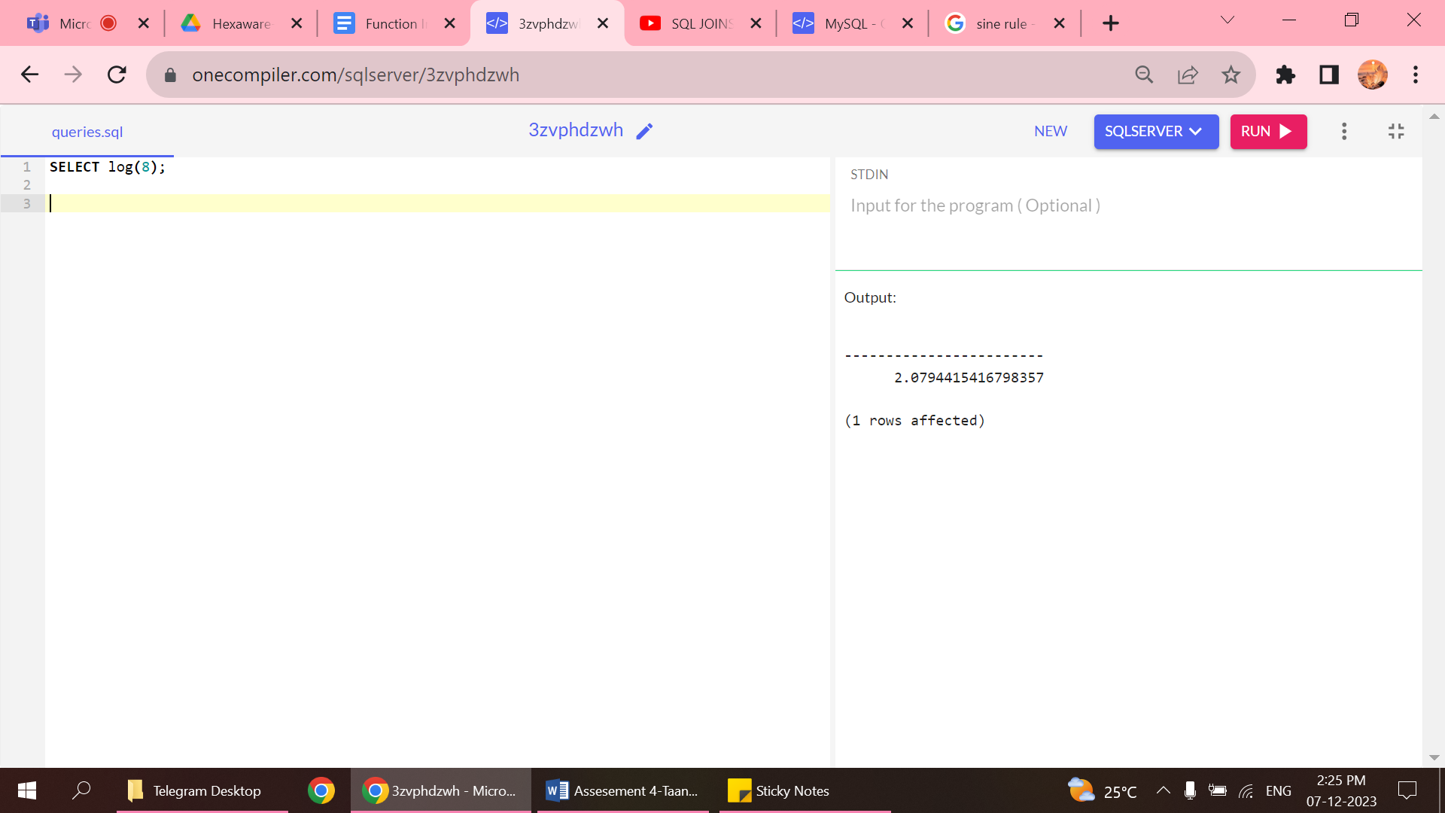

RANK FUNCTIONS

1.row_number

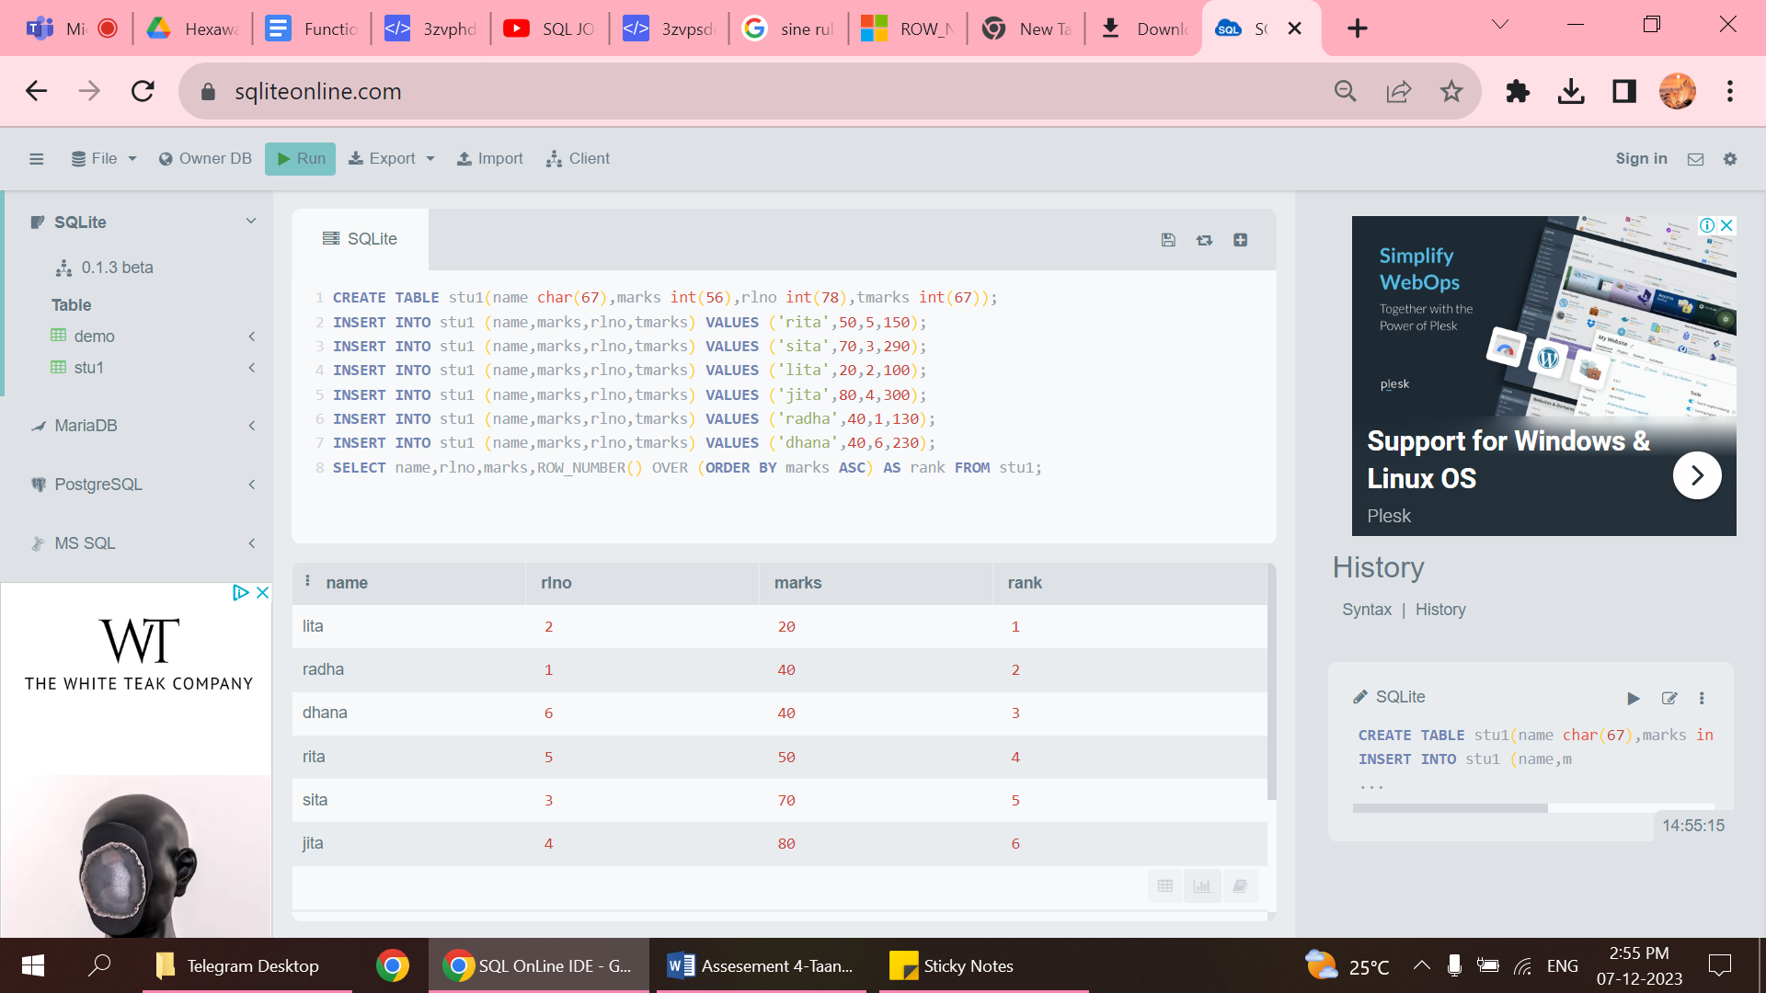

* Sequential ranking for every data.

2.rank

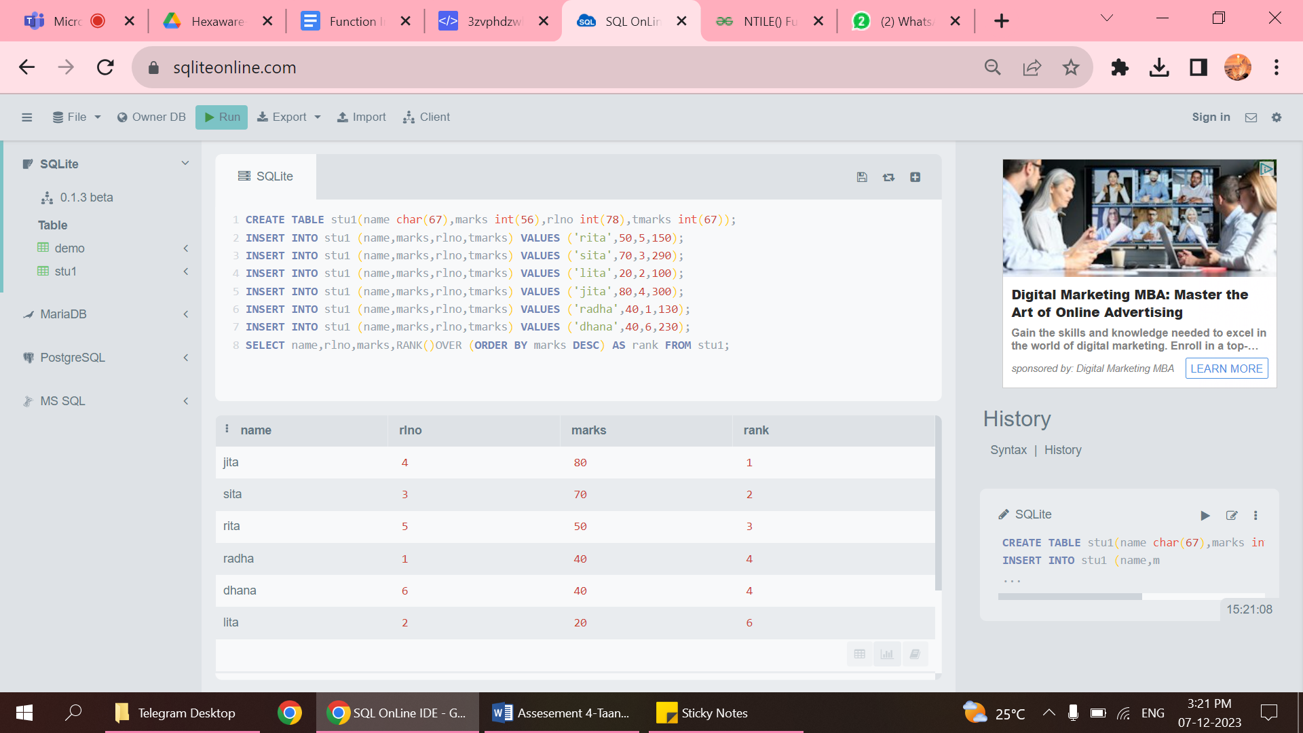

* The rank is given for every column, but if two column contains same value then the next value is not given .(above after 4 6 is given in marks column).

3.dense_rank

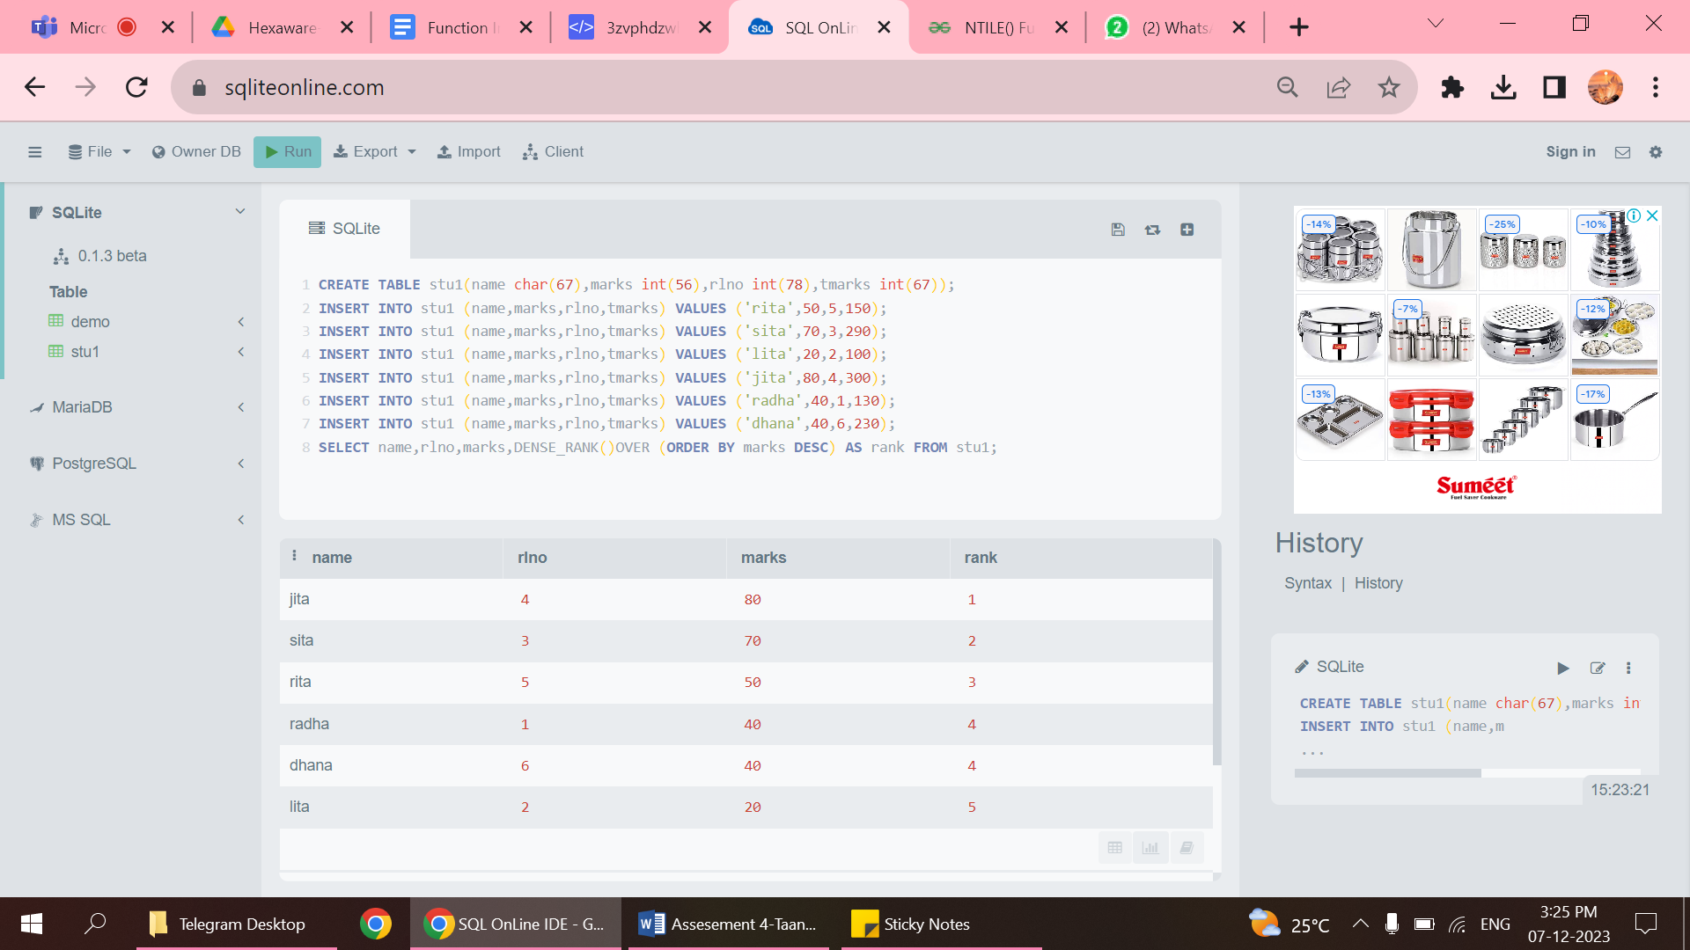

* The main difference between rank and dense rank it gives consecutive values.
* If two column contains same value then the next value is given .(above after 4 5 is given in marks column).

4.ntile()

* This function distributes the rows based on the value that is specified near the ntile keyword. They split the rank based on only that specified value.
* If the value is given as 1 then entire columns get rank 1,if value is given as 2 entire column gets 2 ranks 1 and 2.1st three rows rank 1 and next three columns get rank 3.

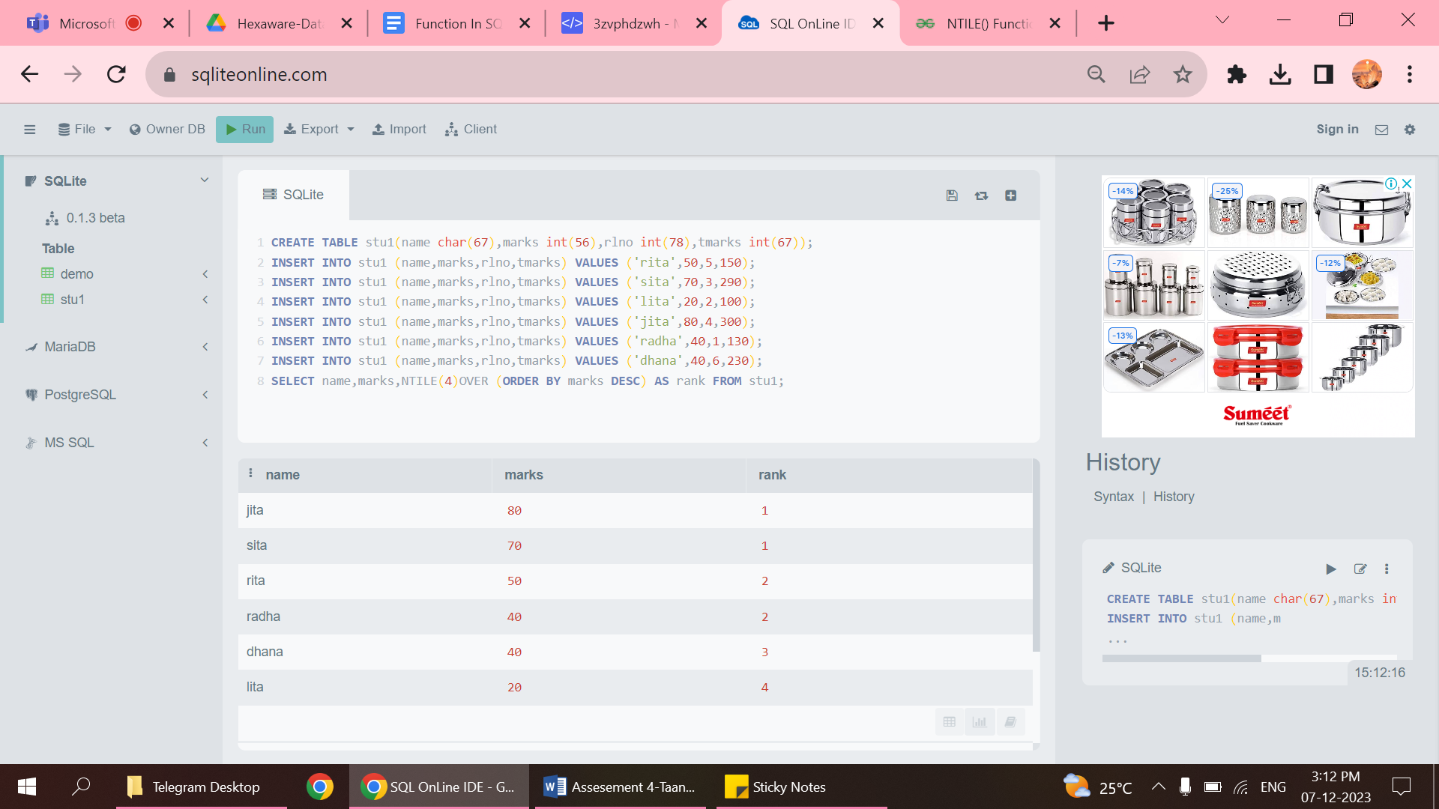

SYSTEM FUNCTIONS

1.HOST

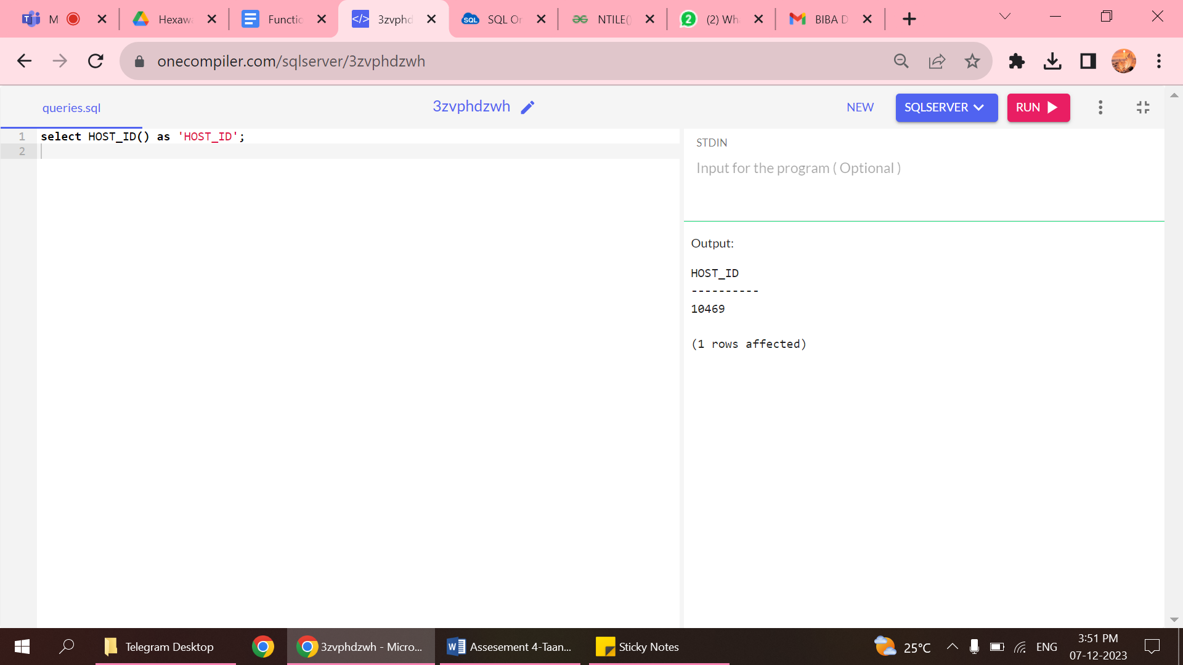

2.IDENTIFICATION NUMBER

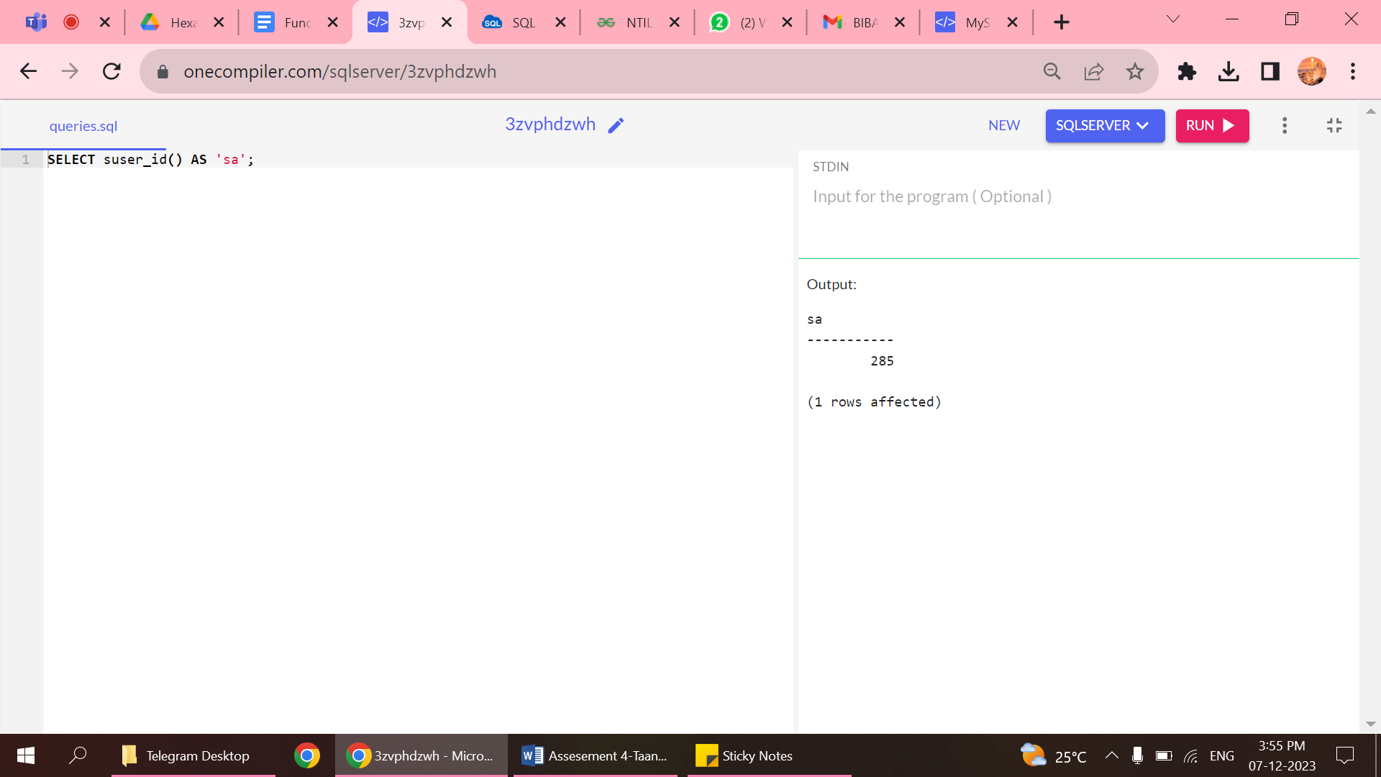

3.DB IDENTIFICATION NUMBER

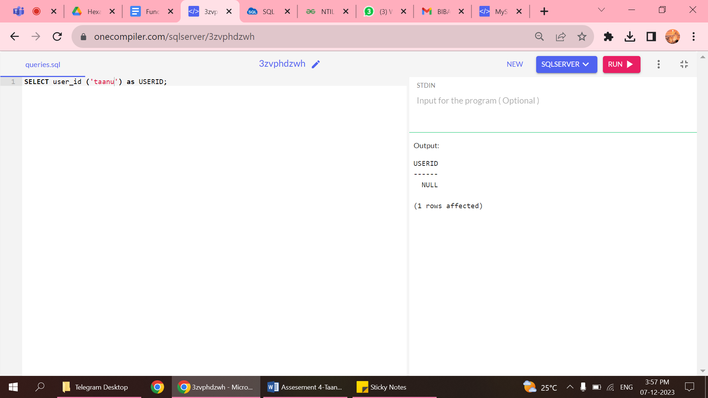

4.DB name

